**1.Diva Apk using MobSF**

Diva has various features that can be used, such as credential input and a simple form that only contains a single field. Android data storage is generally categorized into two types: internal and external. Internal storage gives applications the right to store application data, both cached data and others. On this occasion, I will try to show two features that the Diva has designed to have Insecure Data Storage and Insufficient Cryptography vulnerabilities.

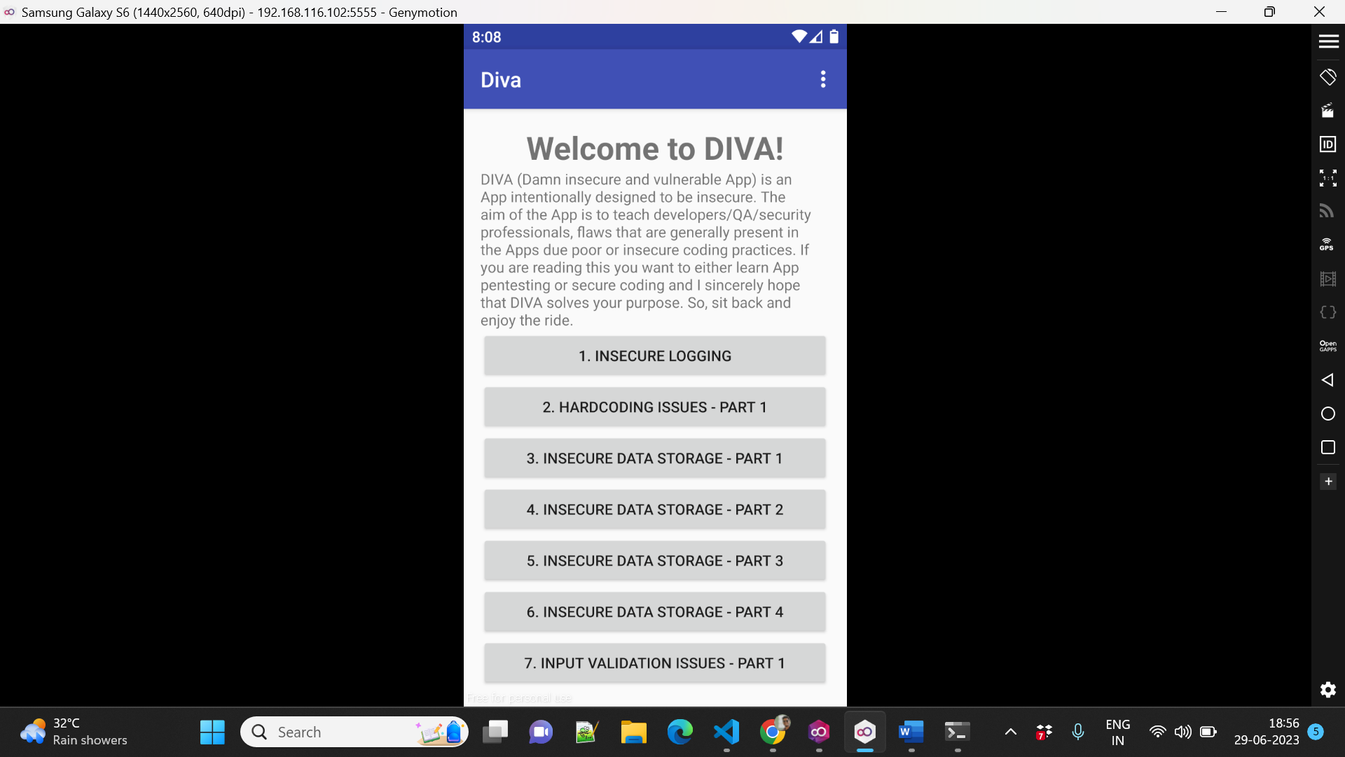

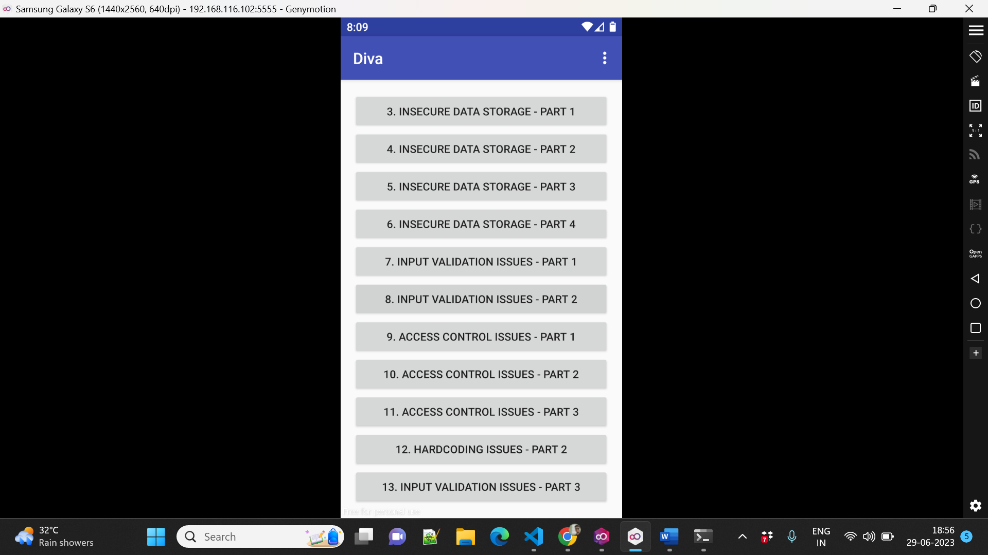

**1. Insecure Logging**

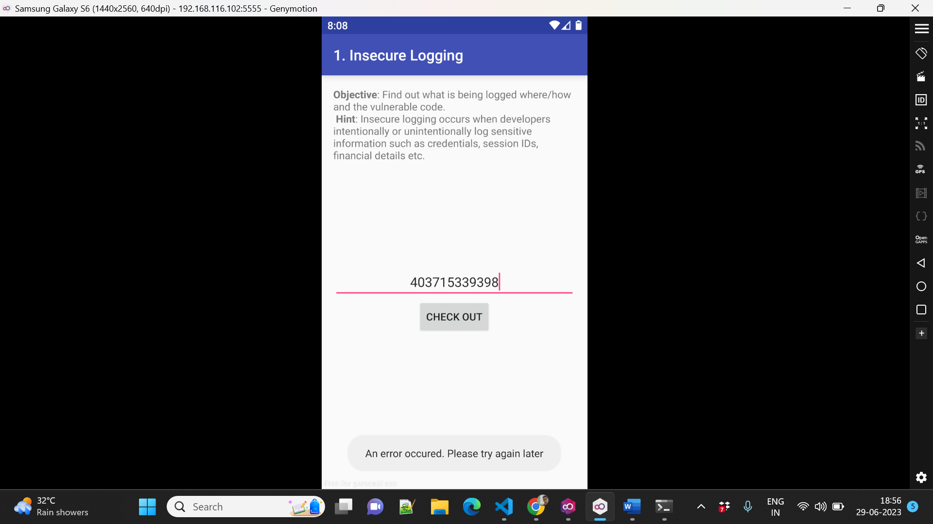

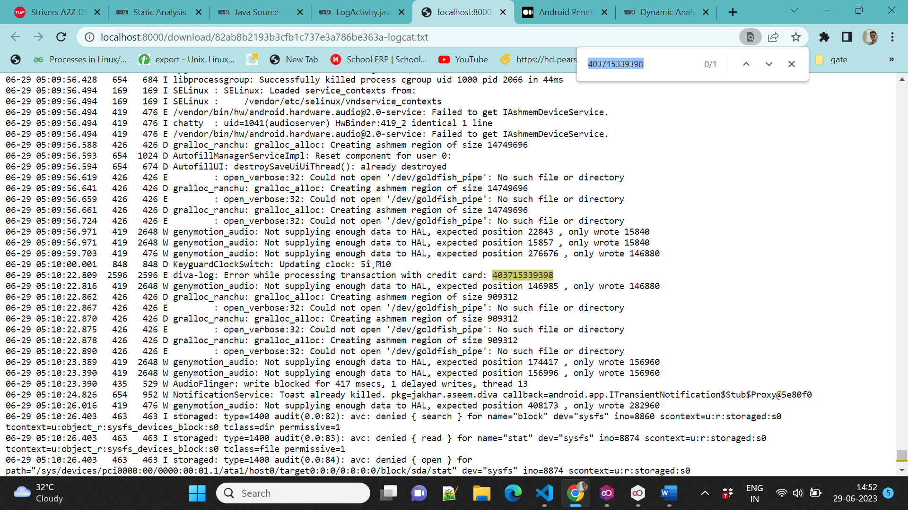

**2. Hardcoded Credentials**

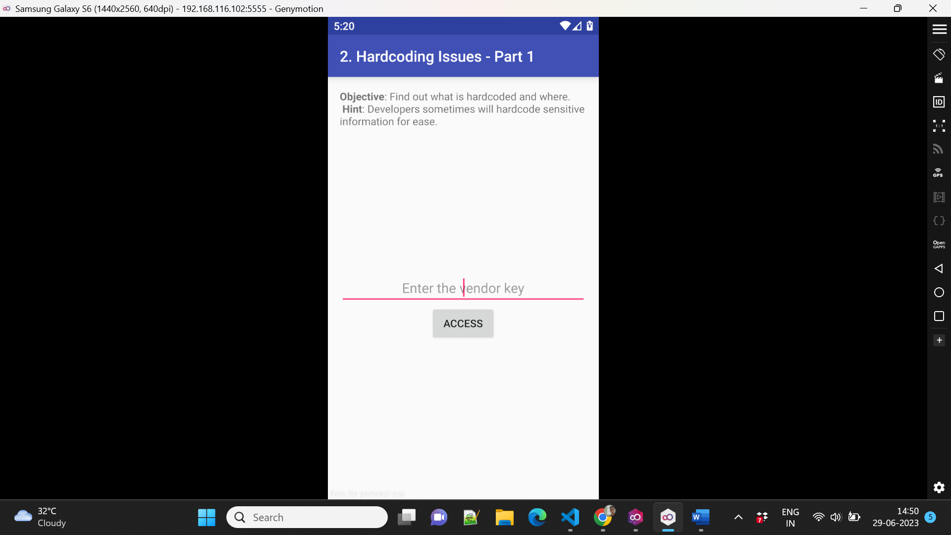

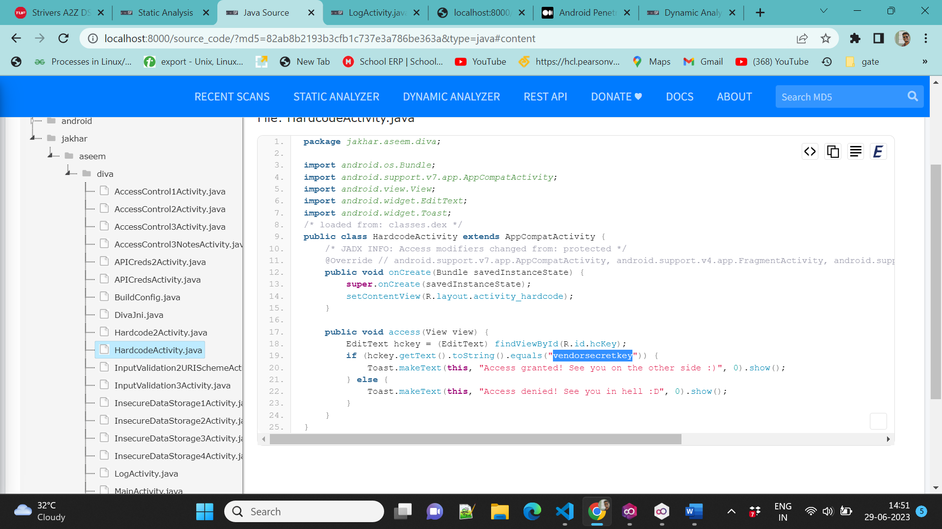

**3. Insecure data storage -Part1**

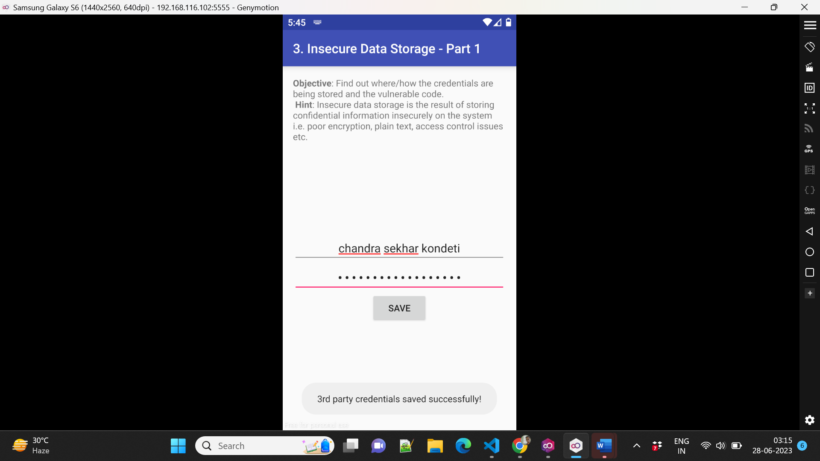

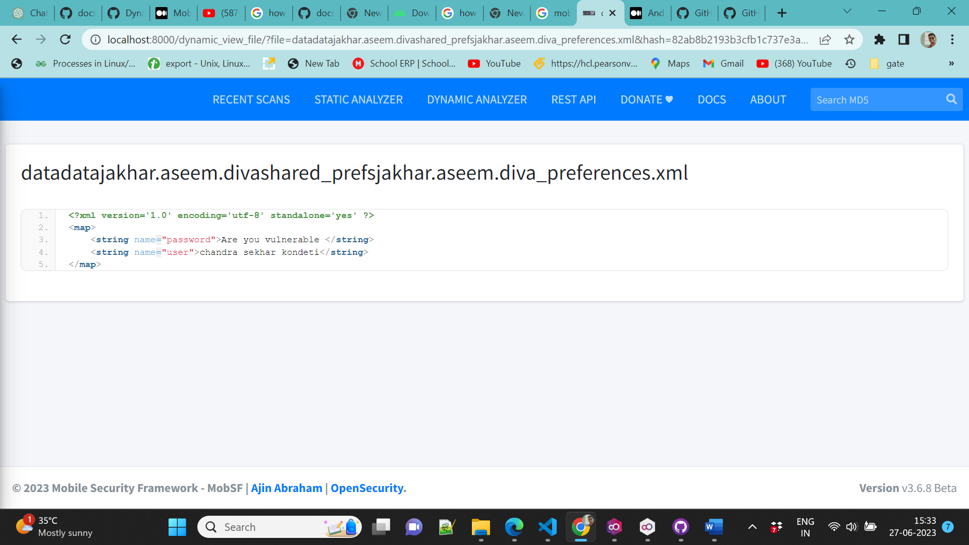

From the XML file, it can be seen that MobSF gets the Diva application using XML as credential data storage. We can see the contents of the credentials entered in the Insecure Data Storage Part 1 feature without any encryption.

**4.Insecure data storage -Part2**

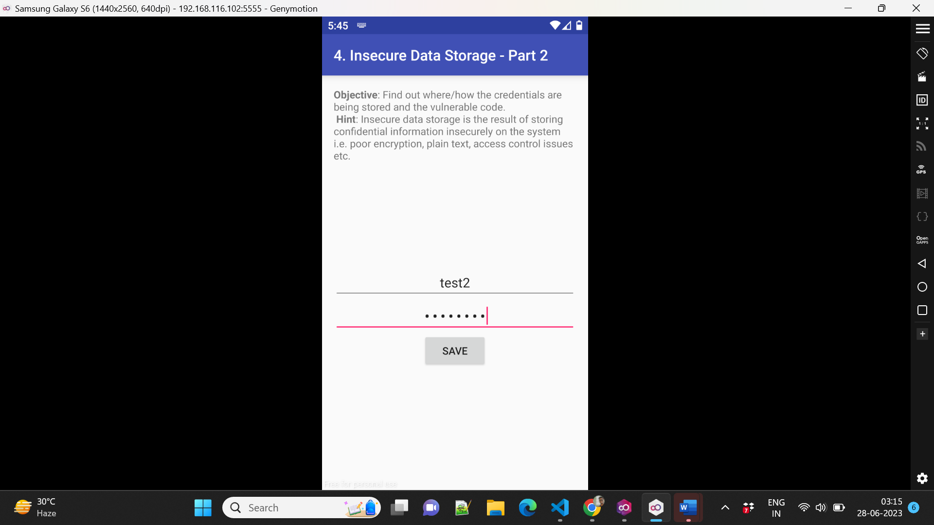

Within the applications directory, we can see a database called ids2 without any encryption at all, so this is a vulnerability in the form of Insufficient Cryptography so that it includes a vulnerability in the form of Insufficient Cryptography. It includes findings due to anyone with physical access to data that has been encrypted improperly or mobile malware acting on an adversary’s behalf.

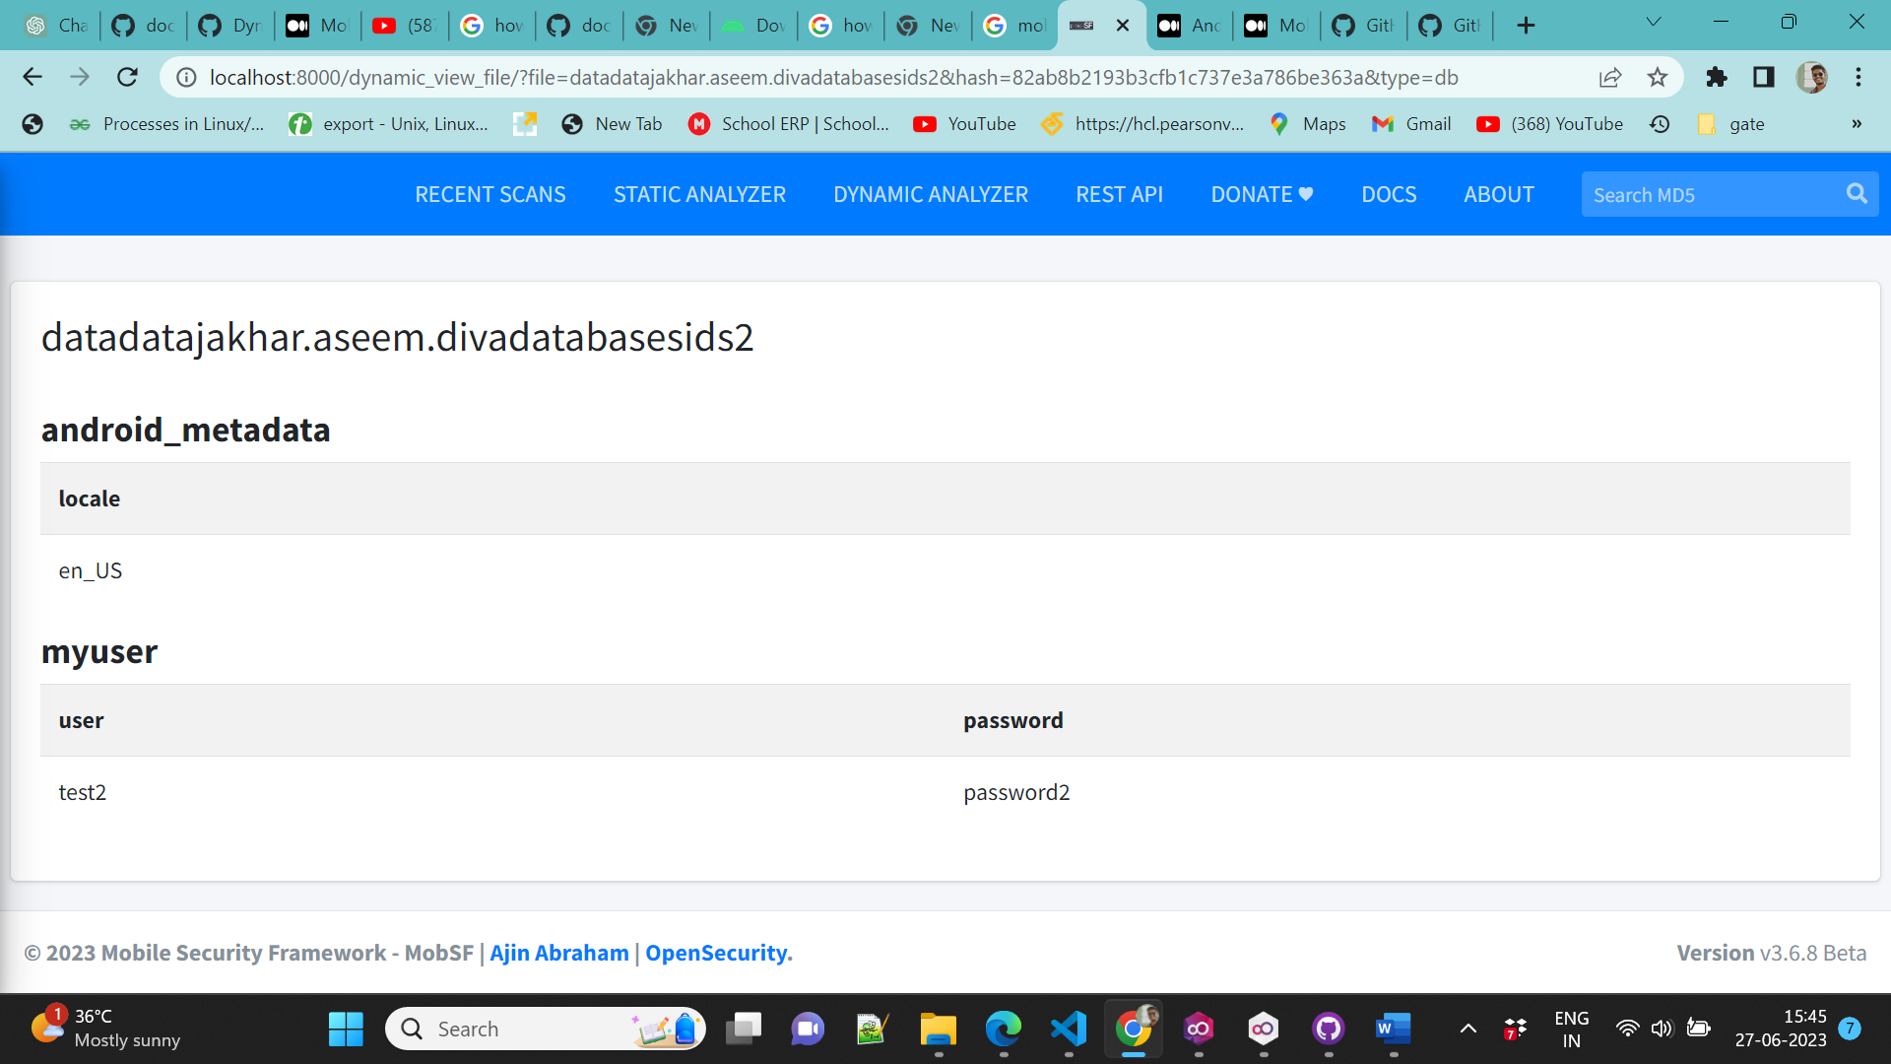

5**.Insecure data storage -Part3**

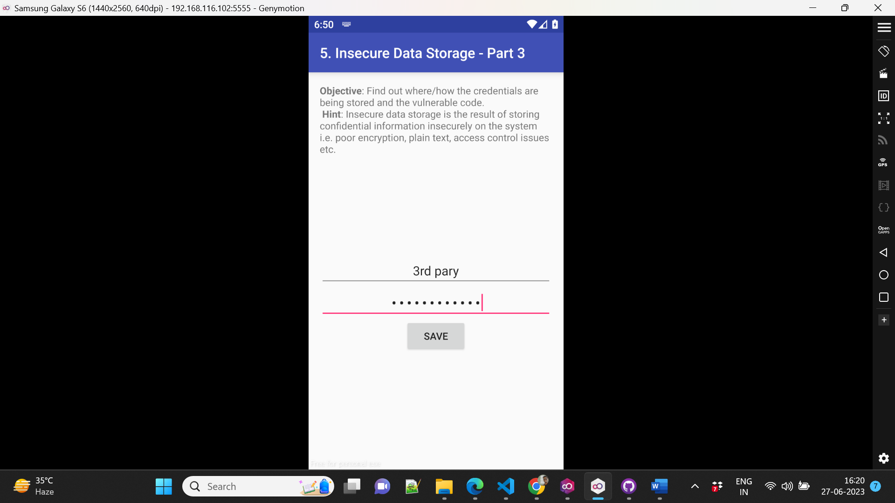

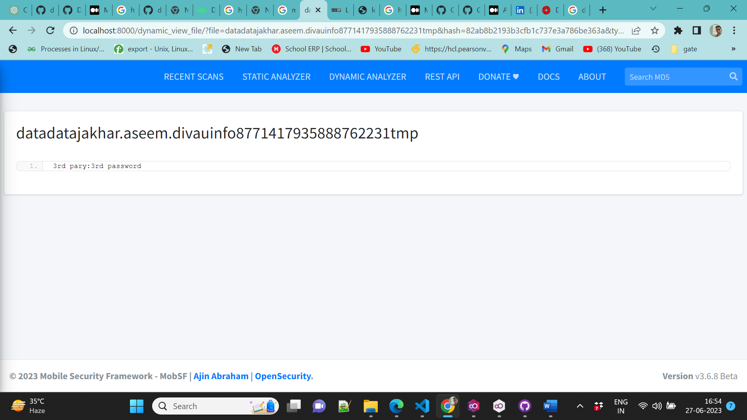

**6.Input Validation Issue**

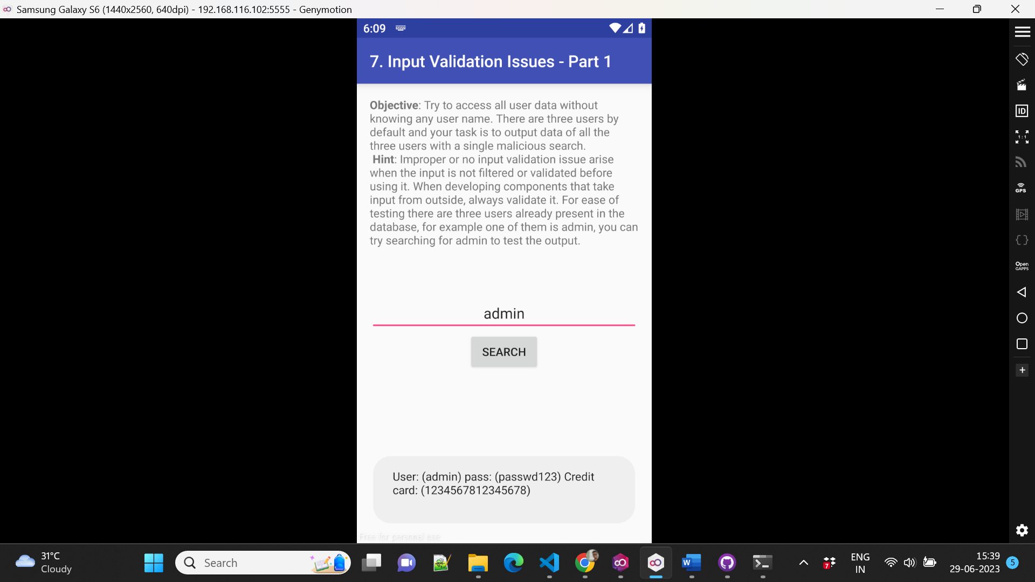

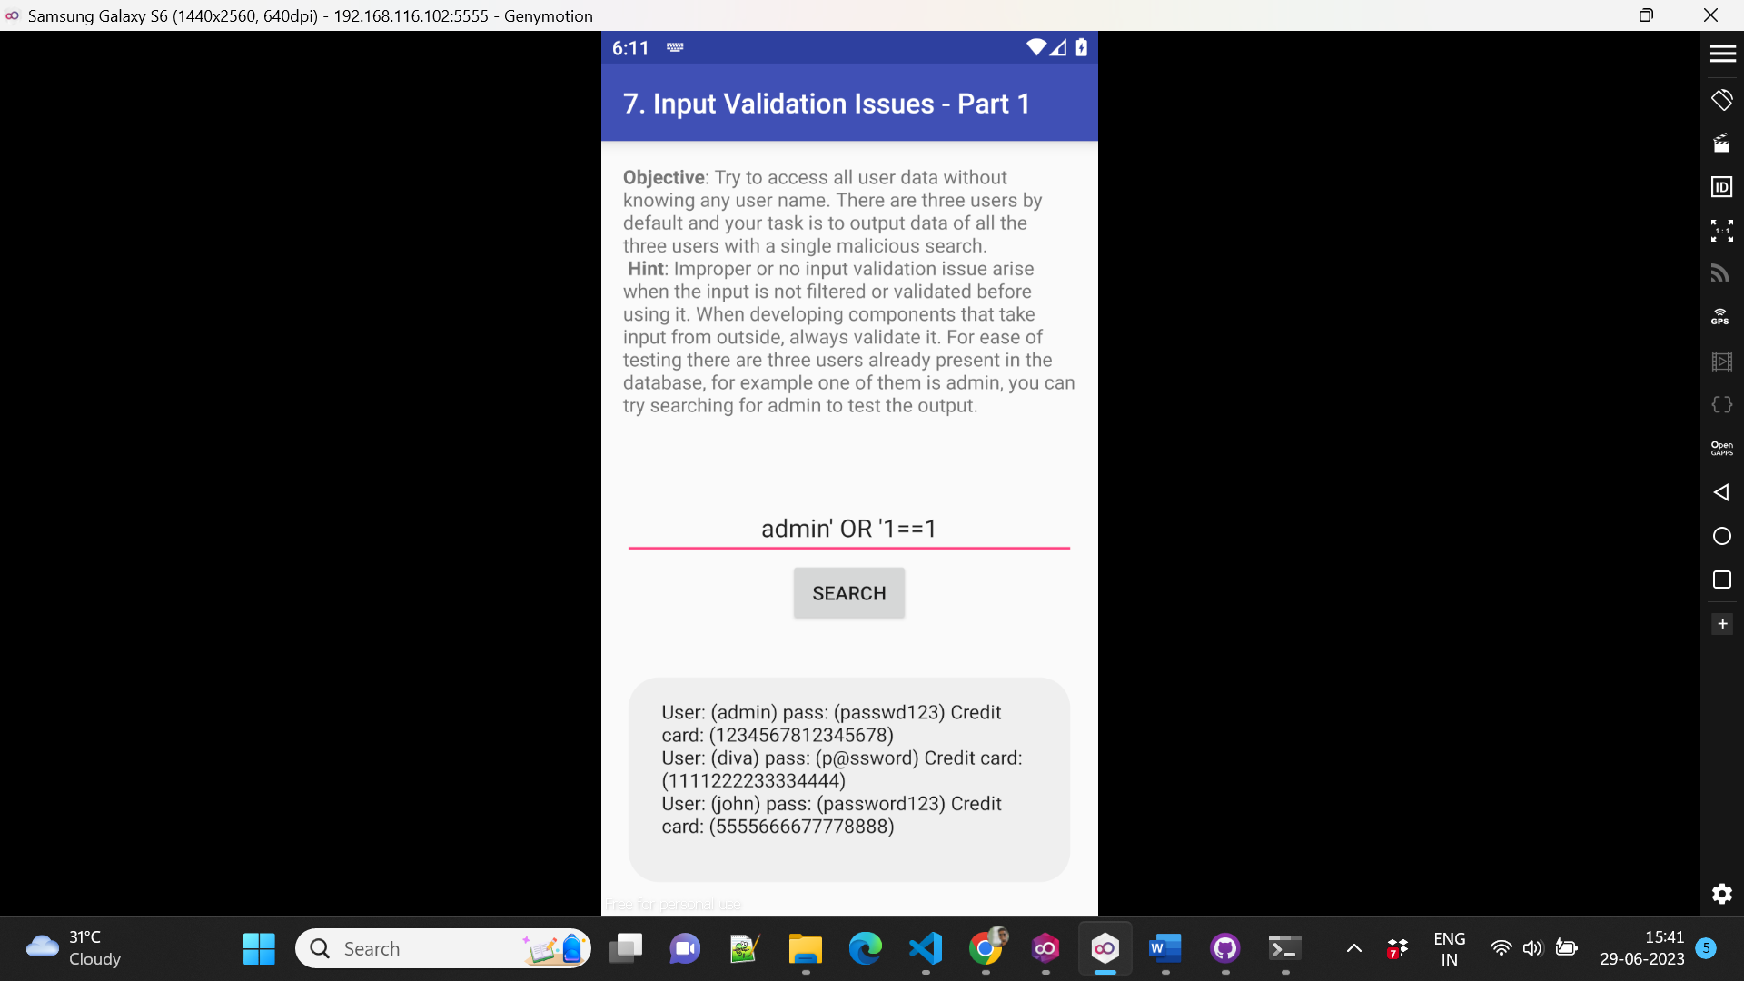

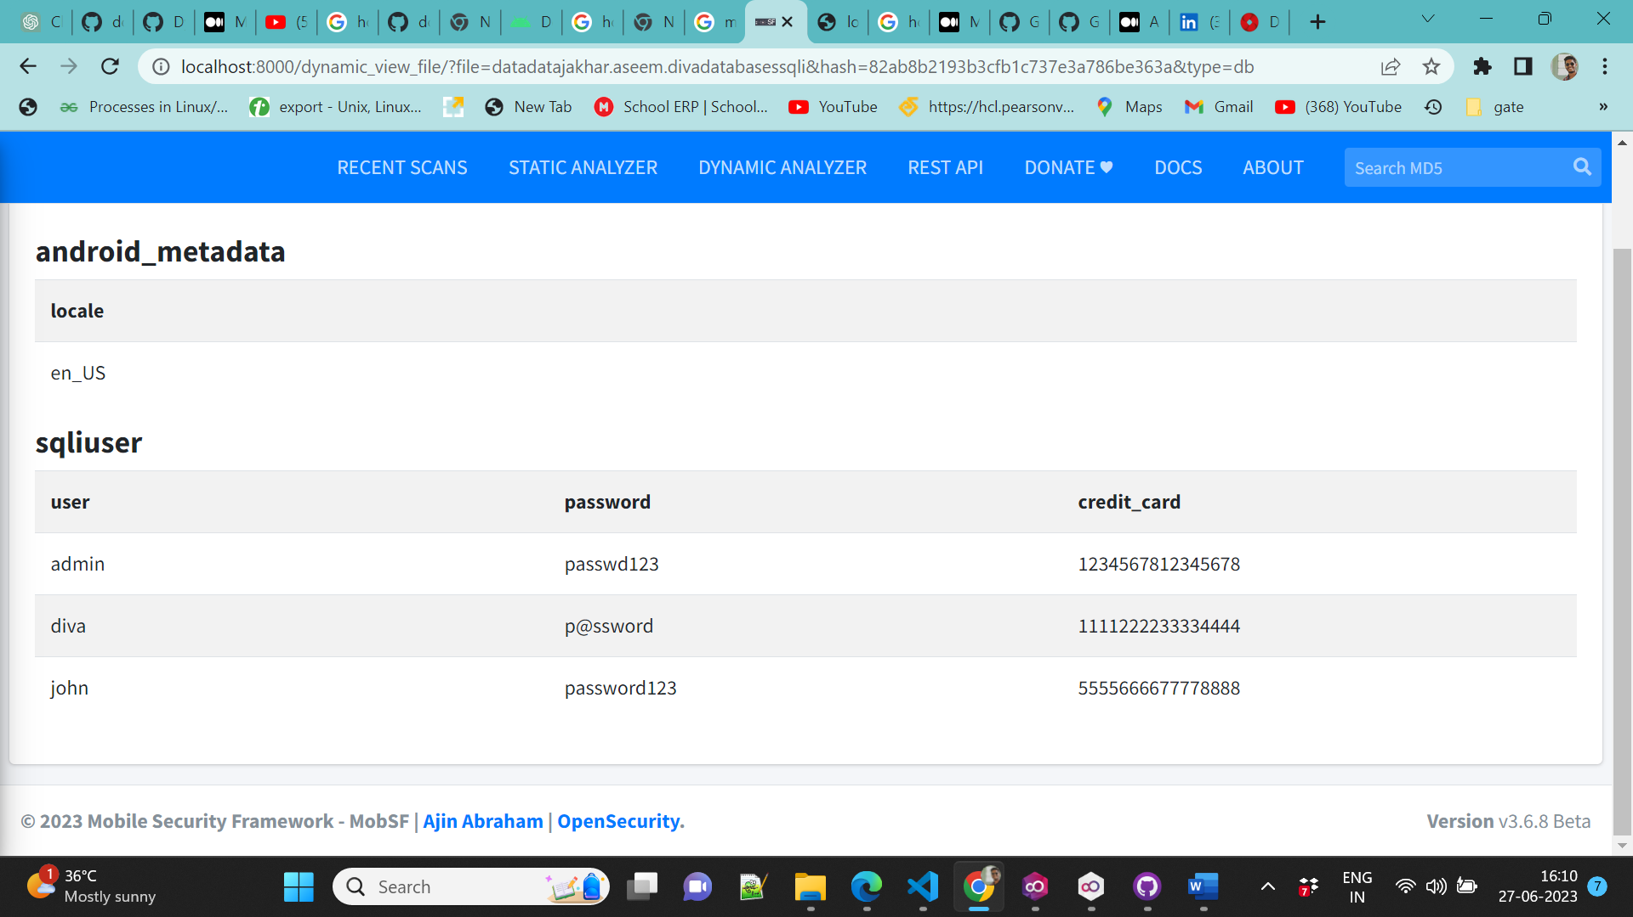

**7. Access Control issues -1**

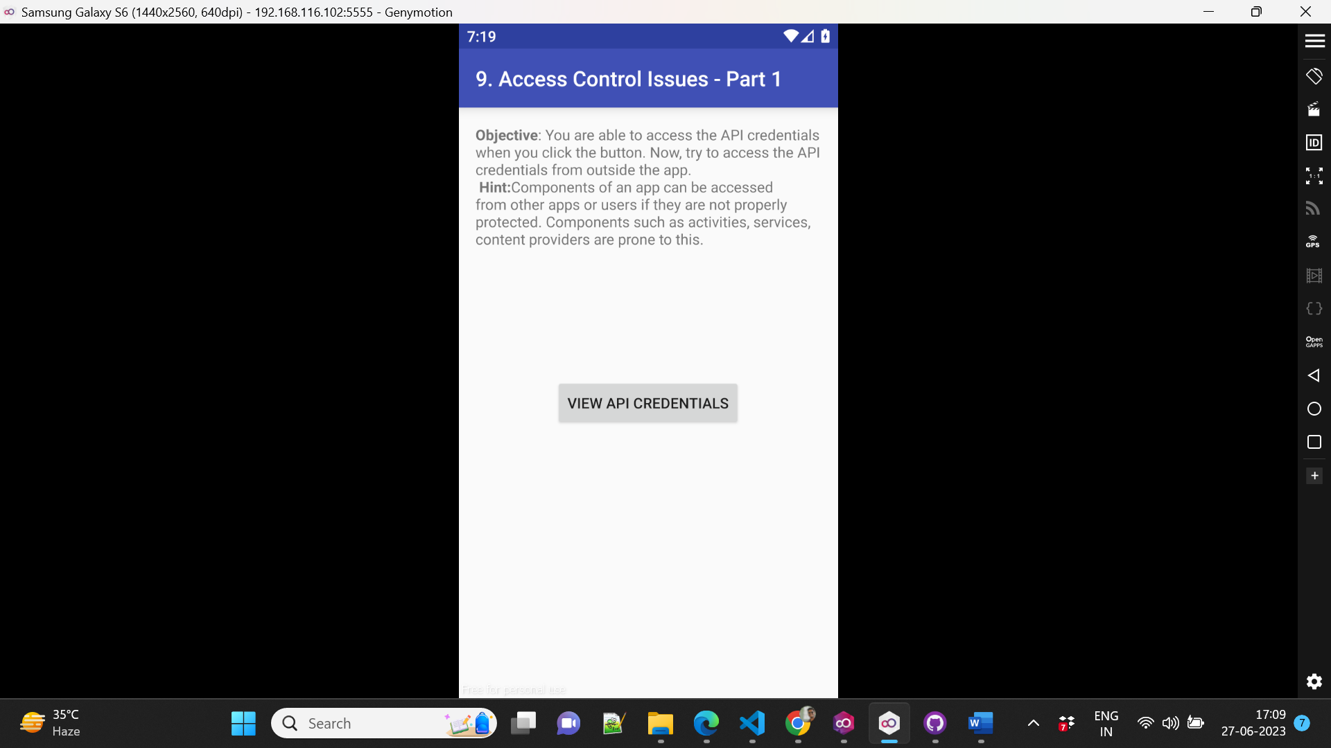

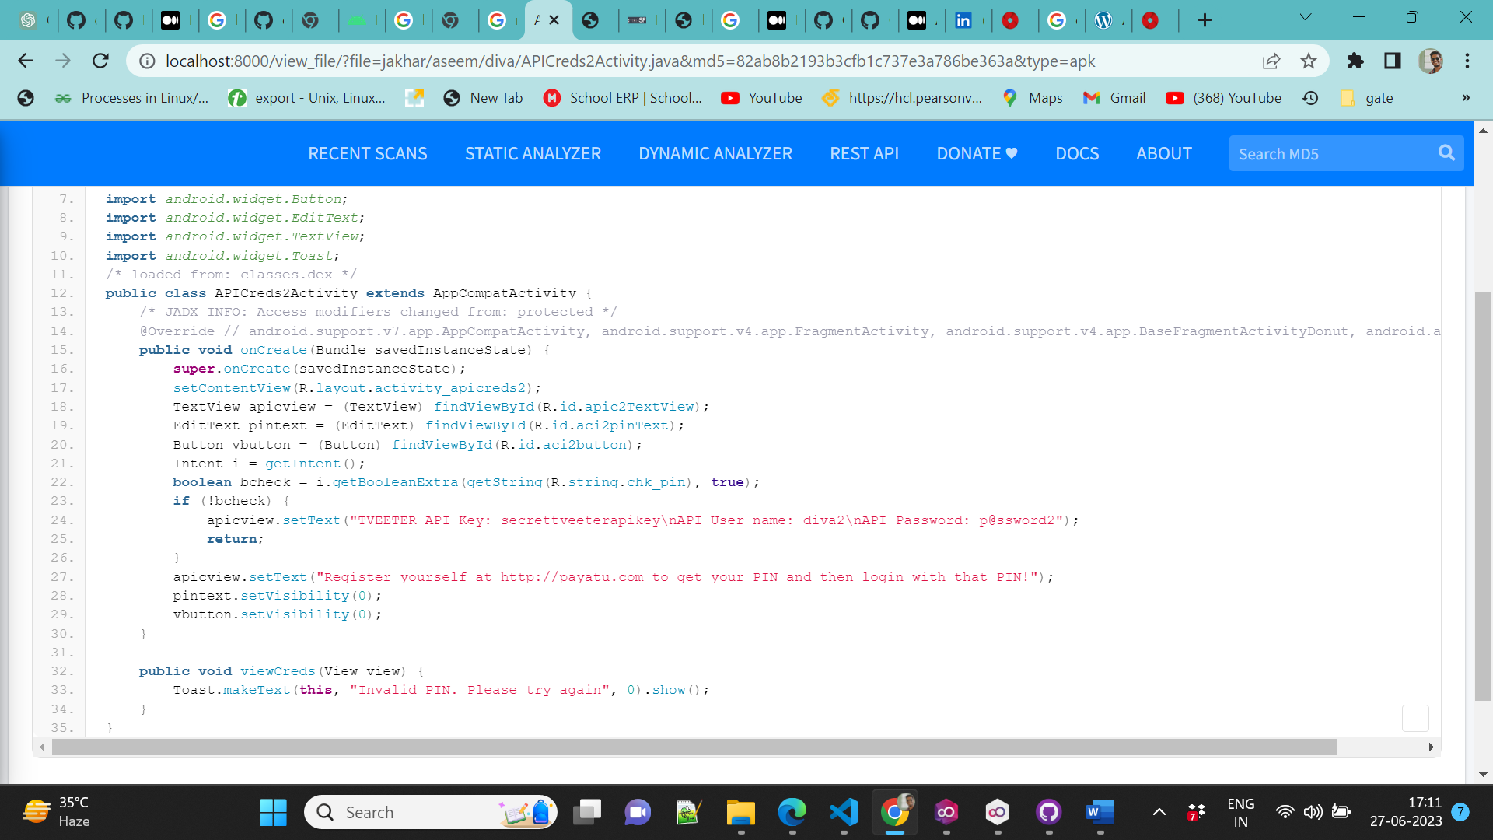

**8.Access control issues -2**

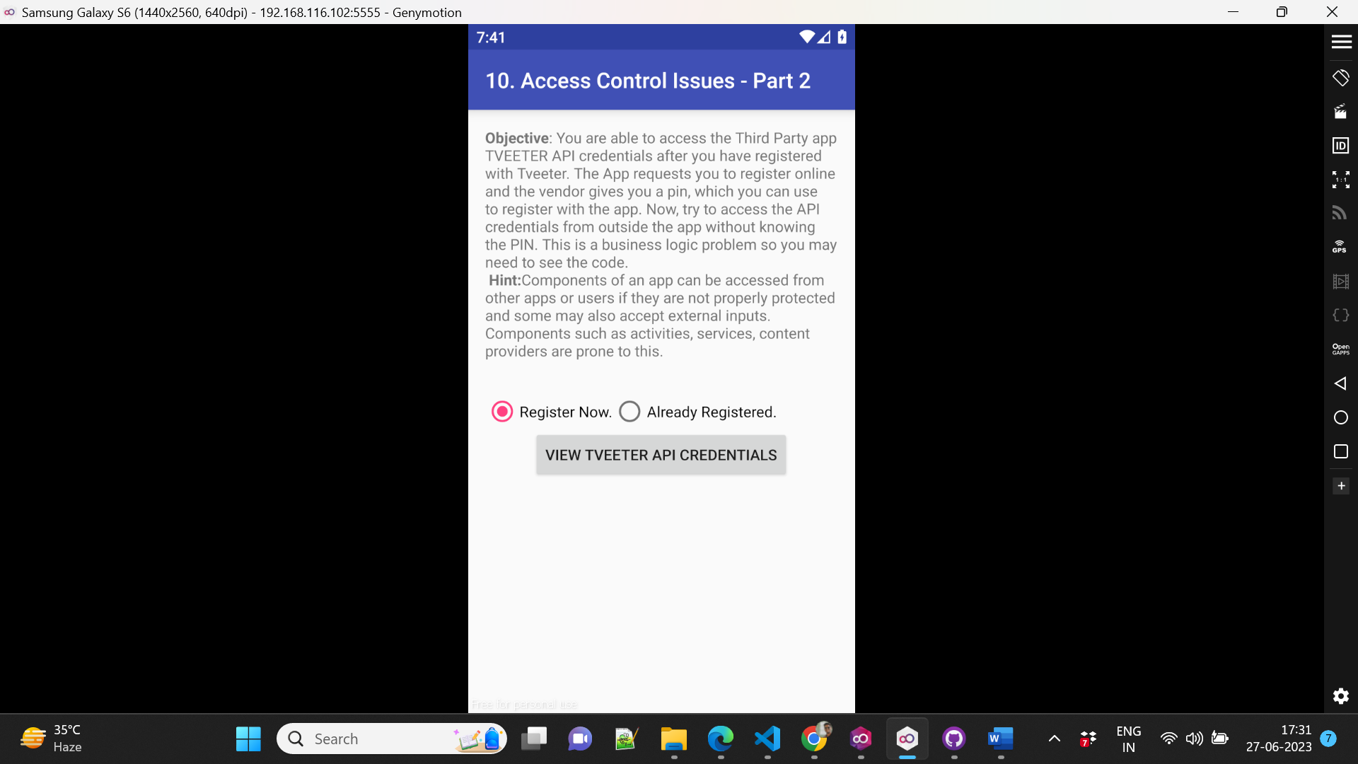

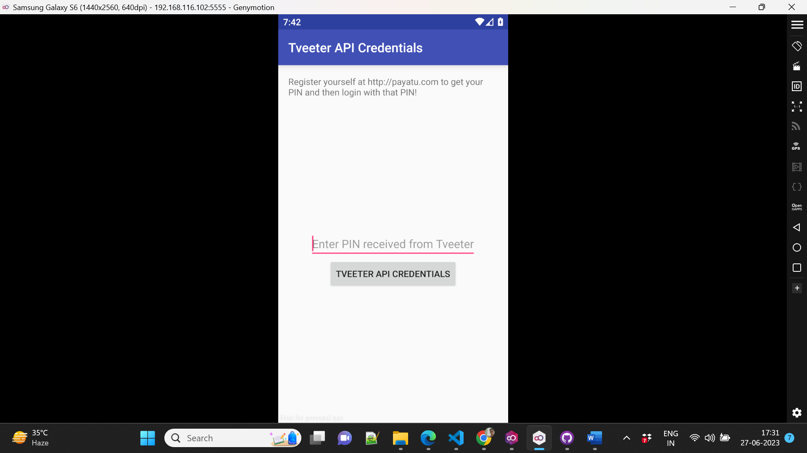

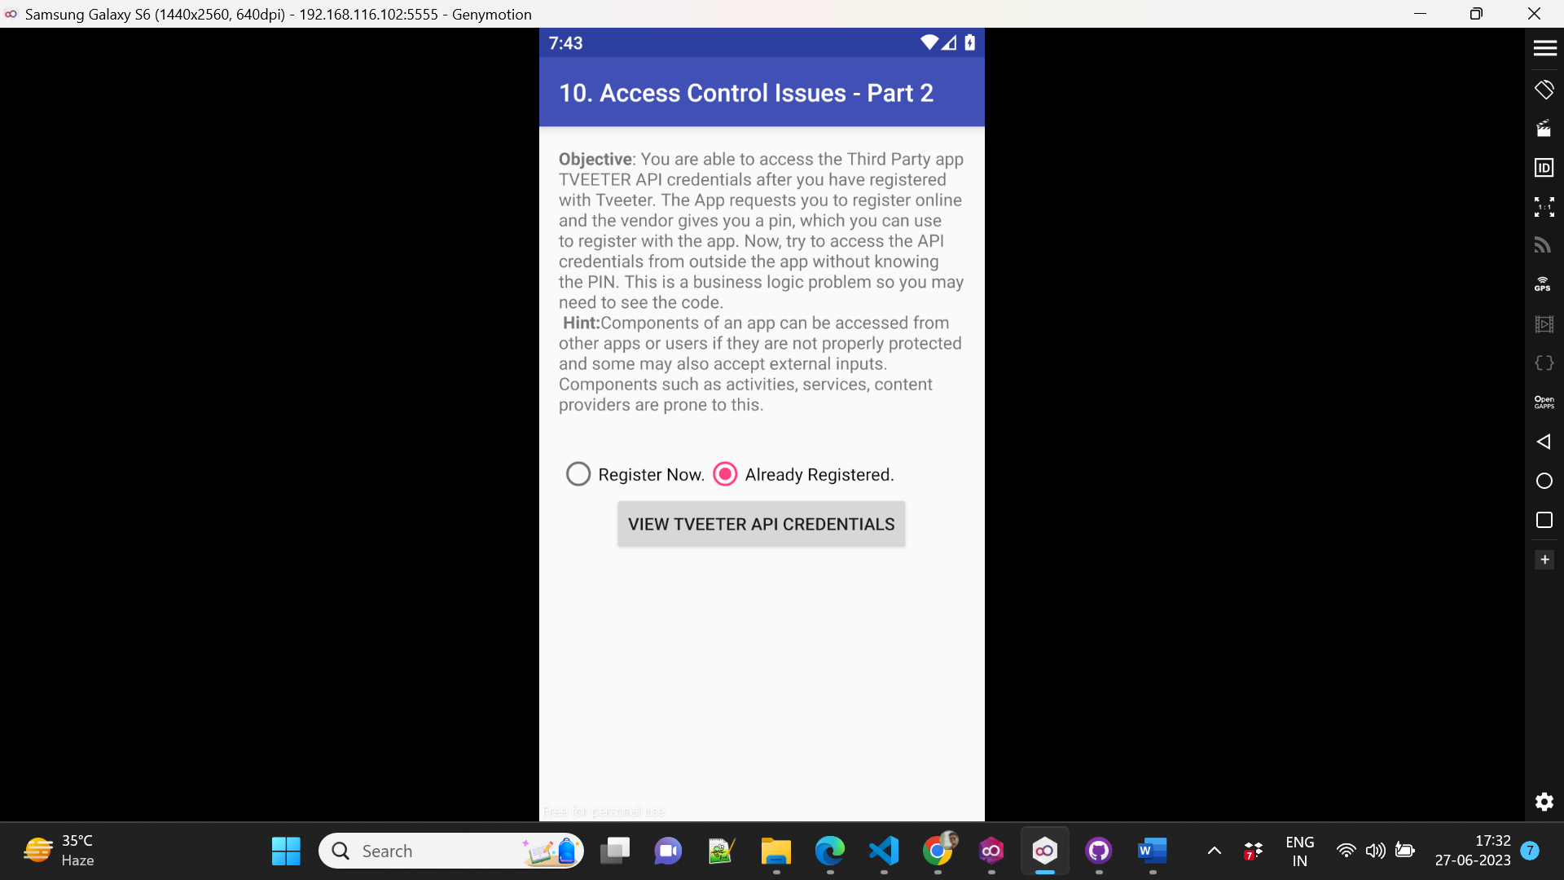

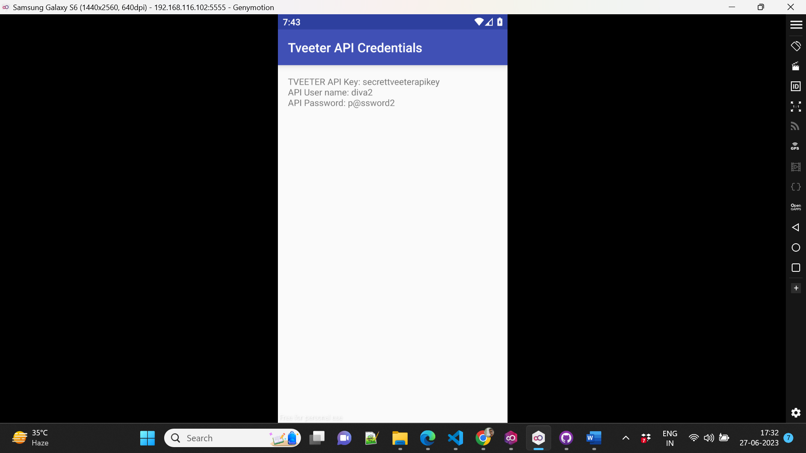

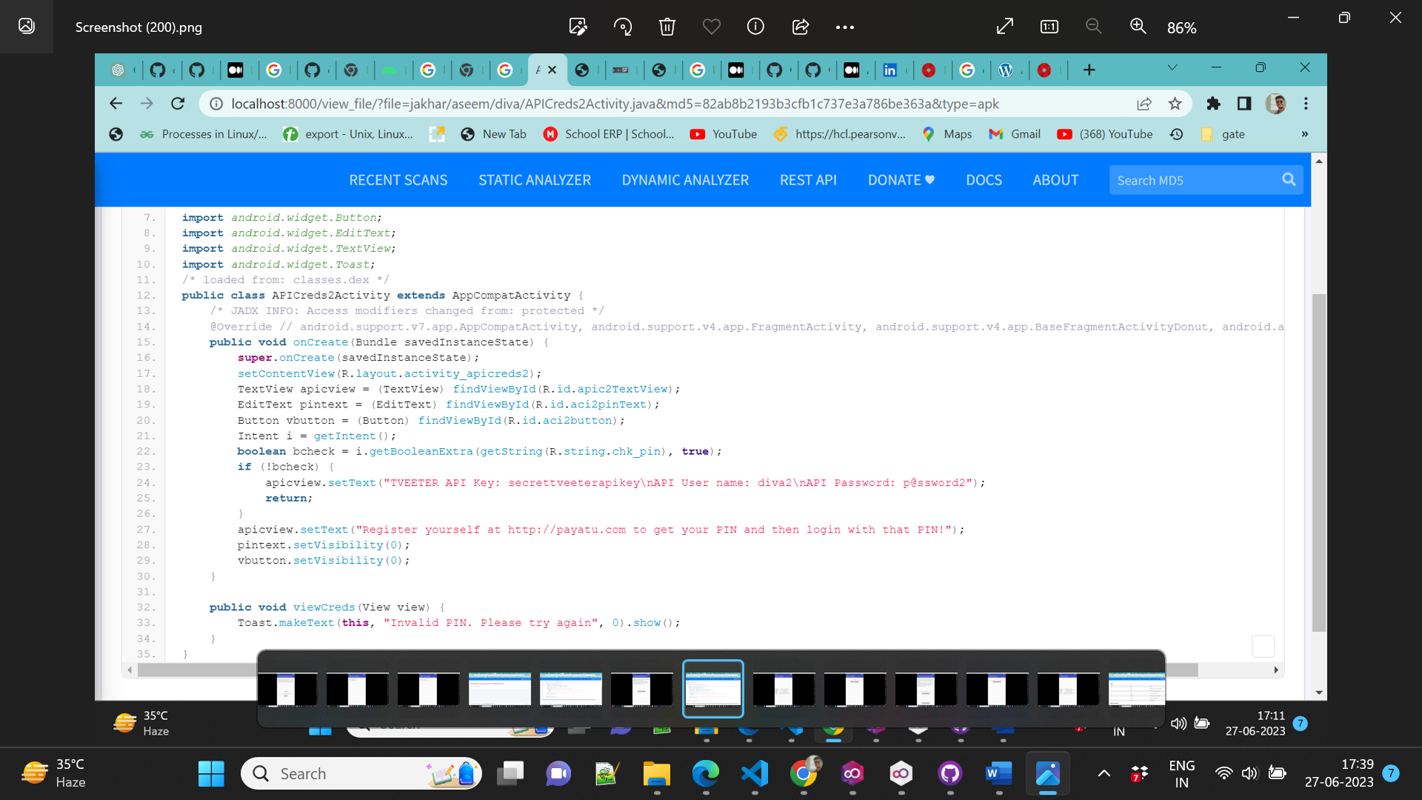

**9. Access control issues -3**

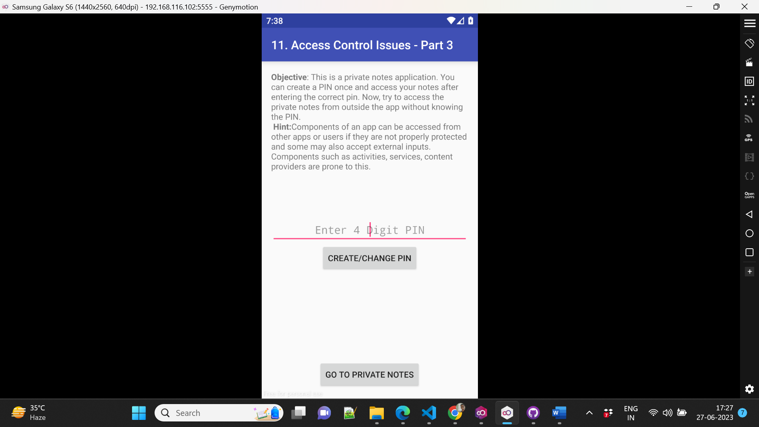

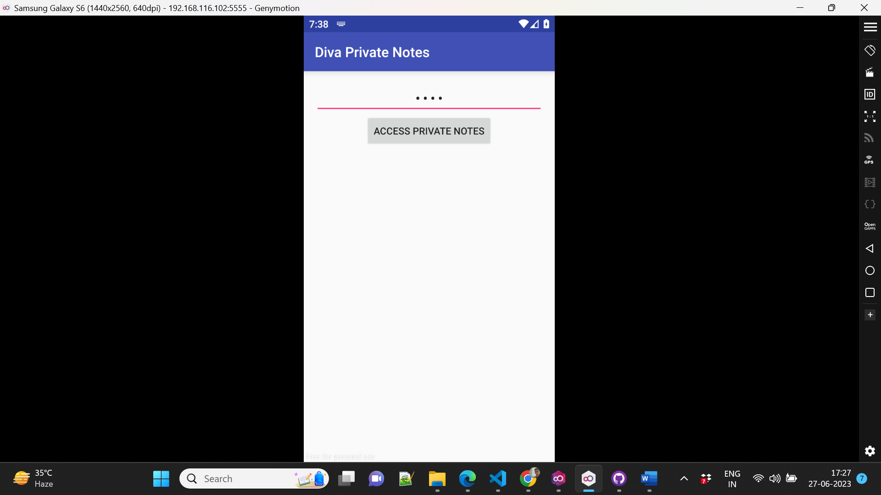

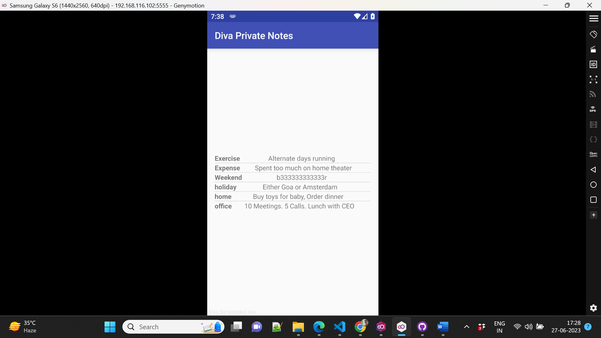

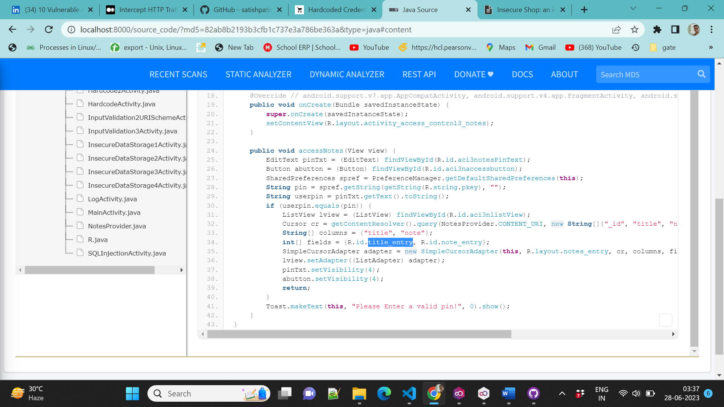

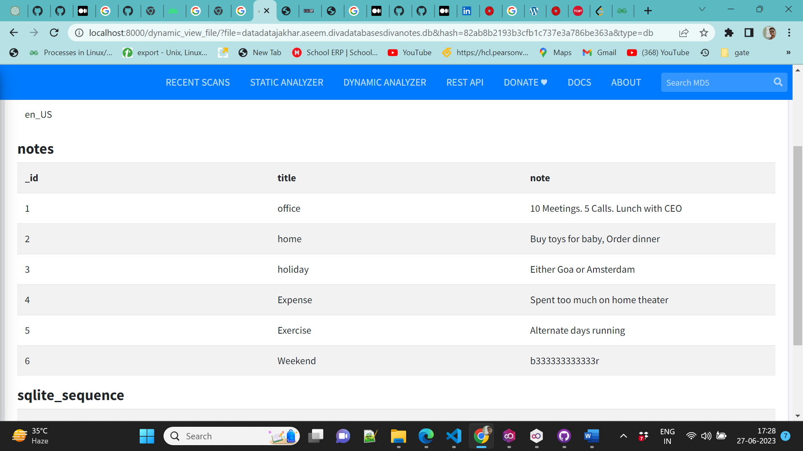

Based on the result of the Diva application, there are sensitive data when using MobSF. It happens because the application still implements internal storage without any special authority. Besides, the data storage is still plain in the text then it can easy to read. MobSF can perform automatic scans on every feature of the application but cannot perform special intercept, so it still needs to be tested manually to ensure vulnerabilities in the application.

**10. Input Validation3**

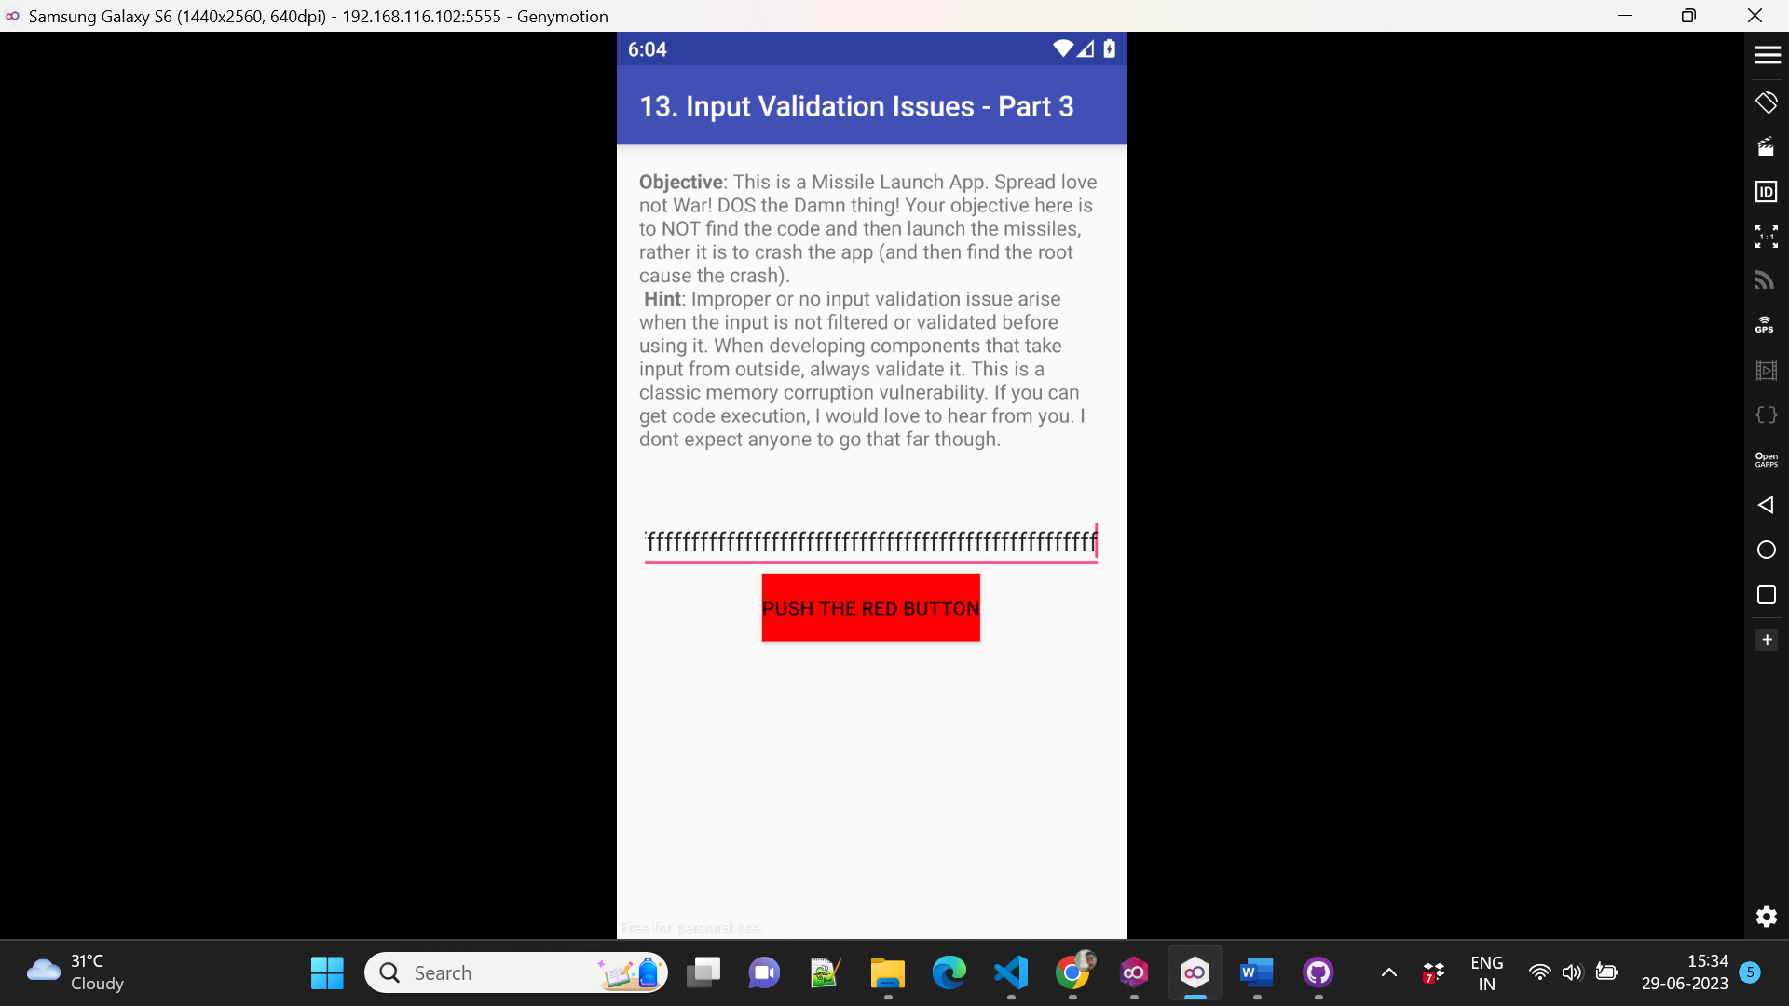

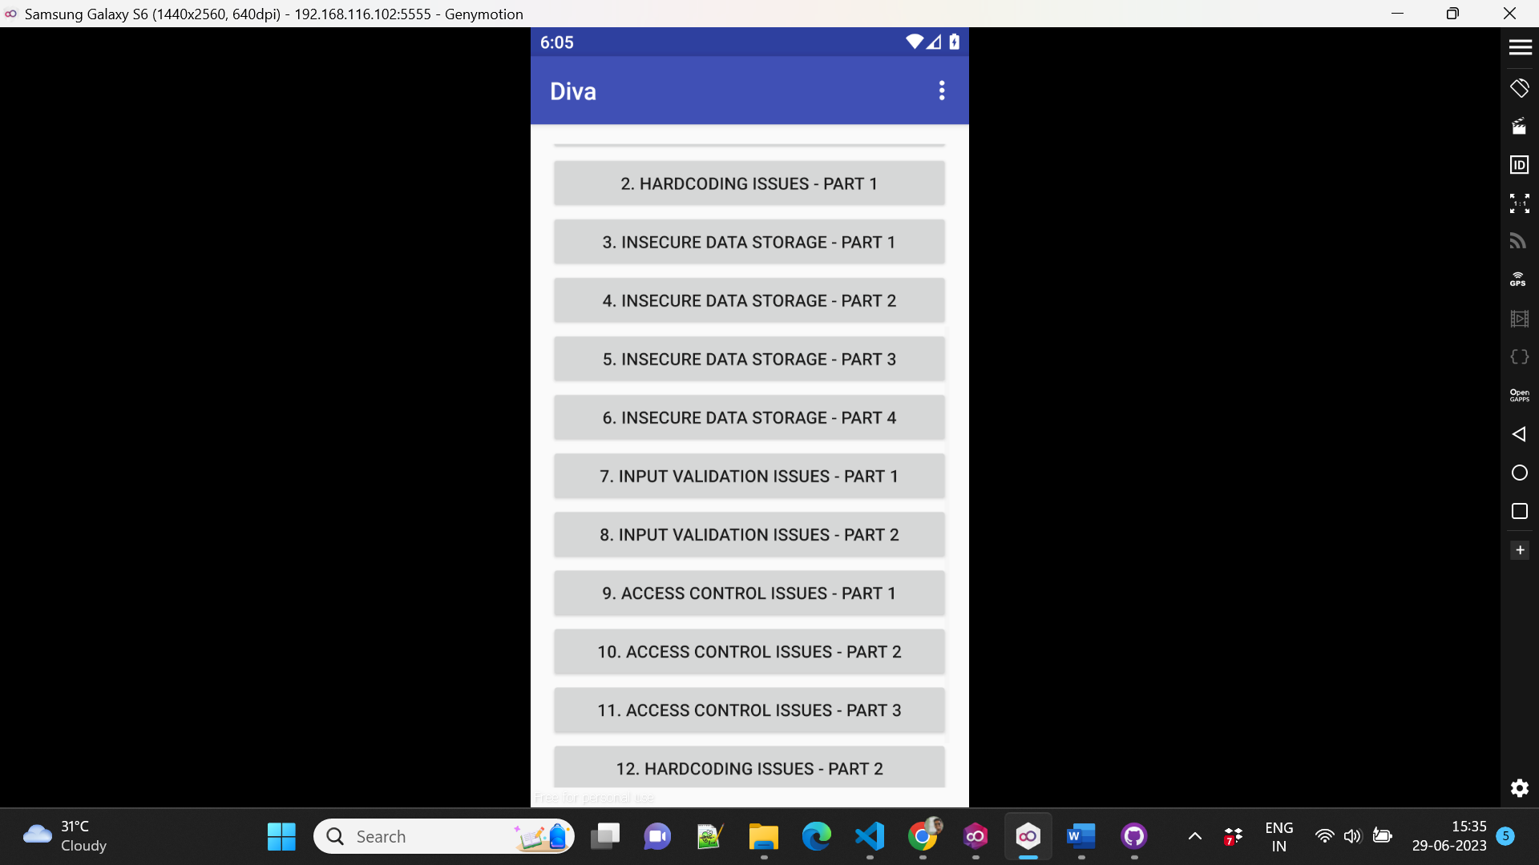

**2.Insecure shop using MobSf**

**1.Insecure Logging**

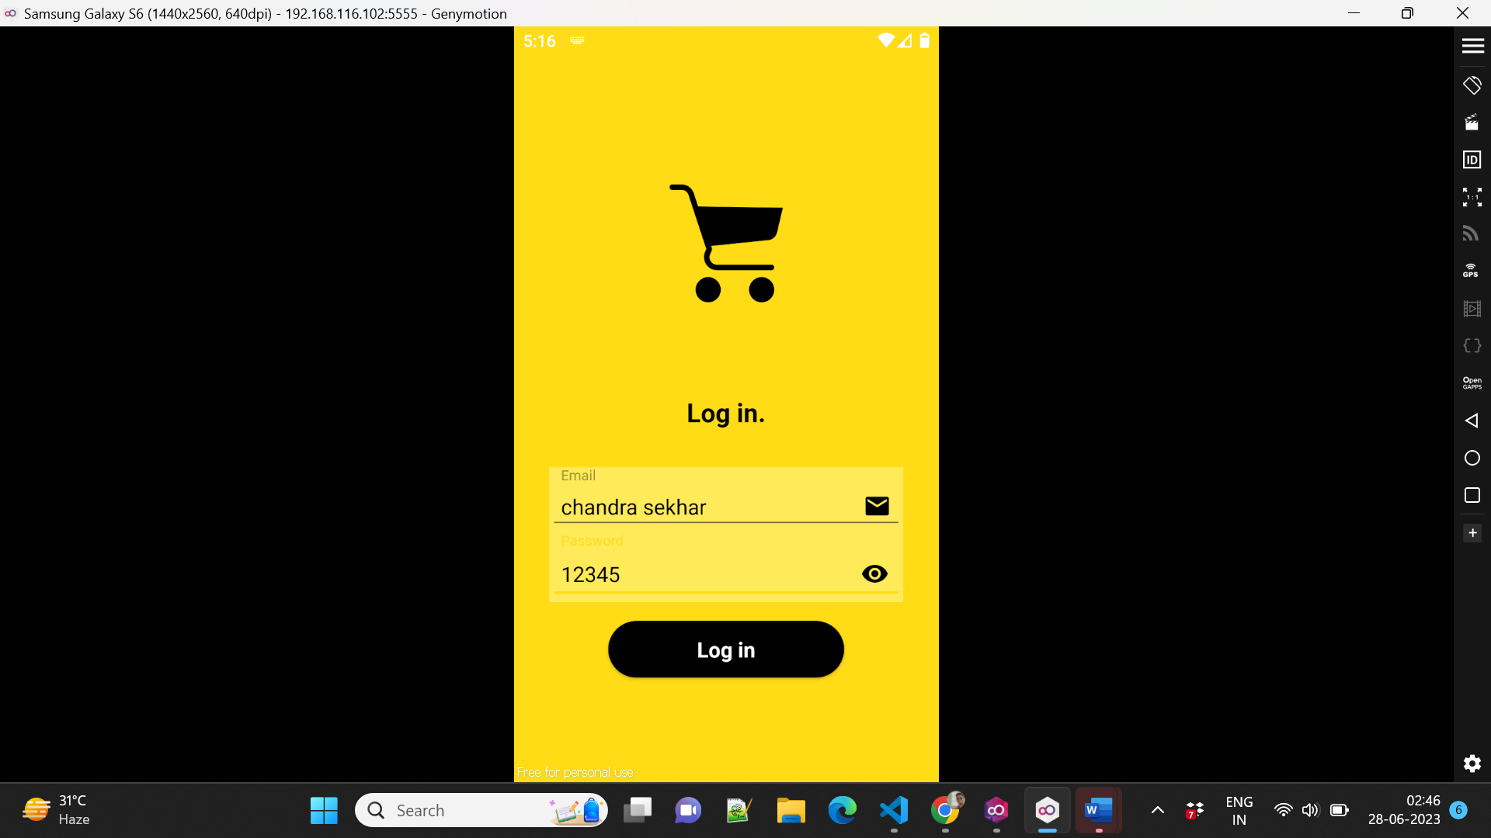

Now the entered credentials will log in to “LOGCATS”. Now this information will help us to get the actually to get actual credentials also because the entered credentials will be checked with the actual credentials. If it is a match then it will allow us into the app otherwise don’t allow us to log in here there is a catch actually when it checks may be checking information is hardcoded that we need to check.

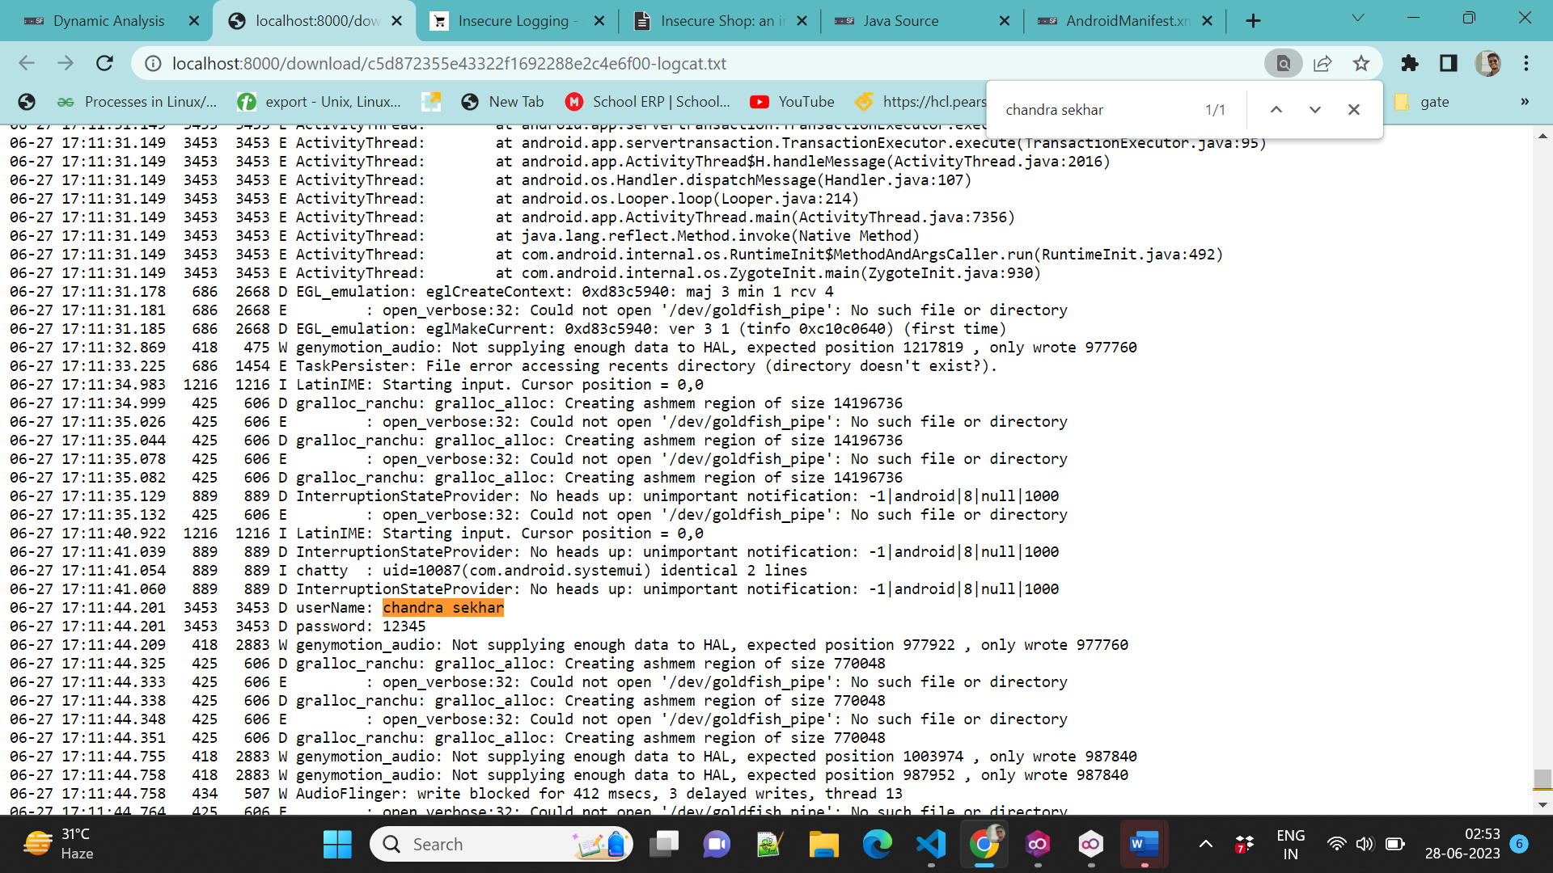

So here the logging information is disclosed.

**2. Hardcoded credentials**

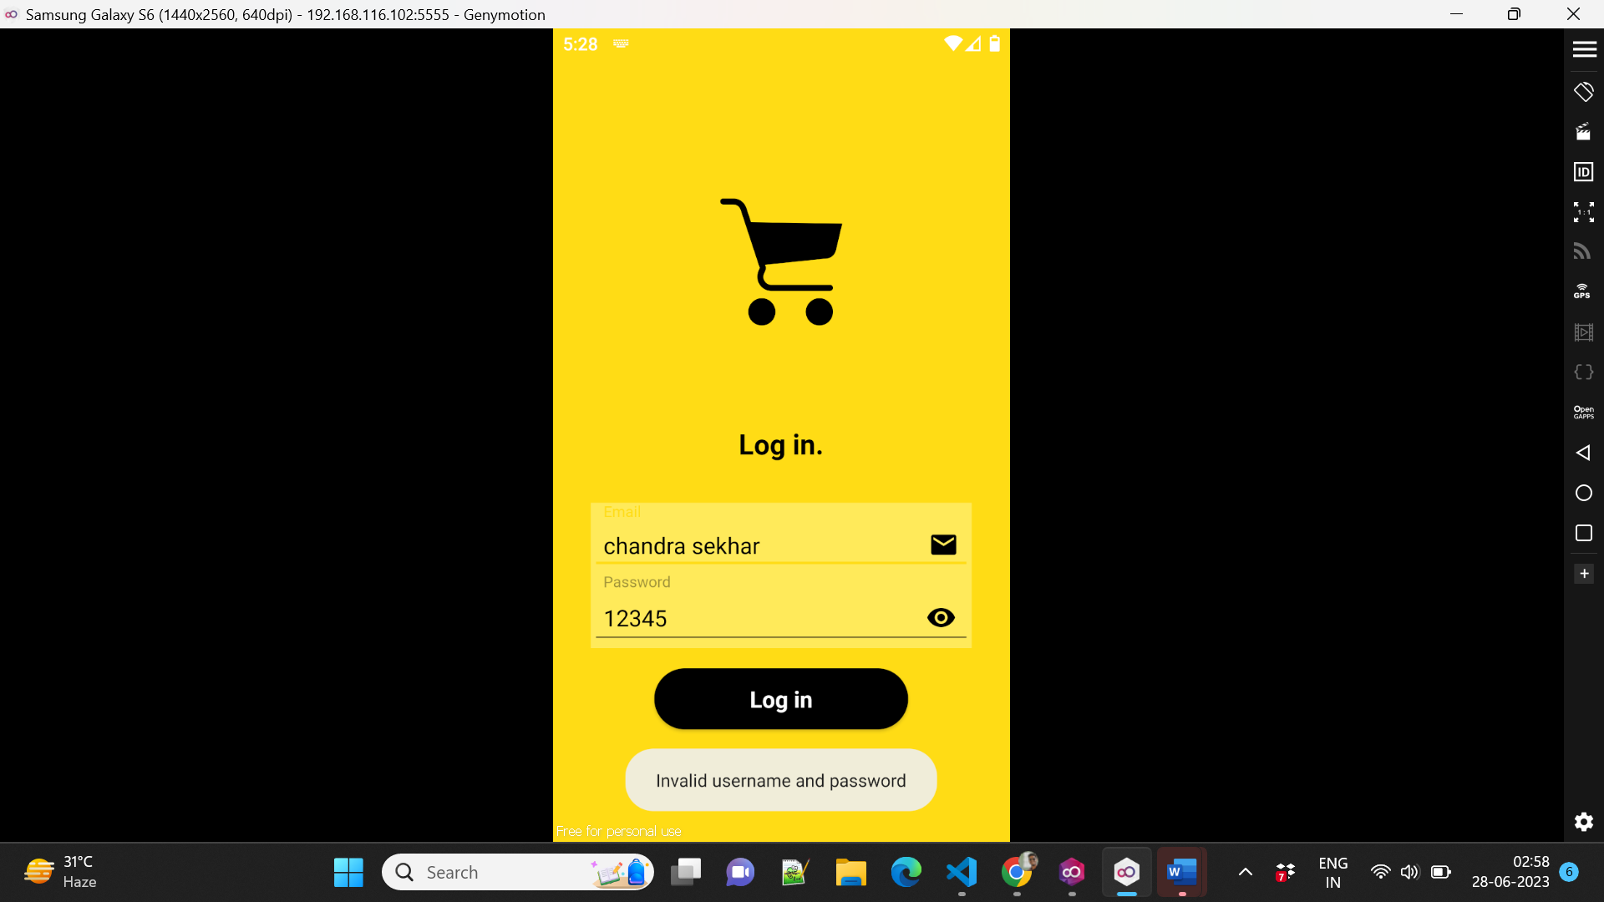

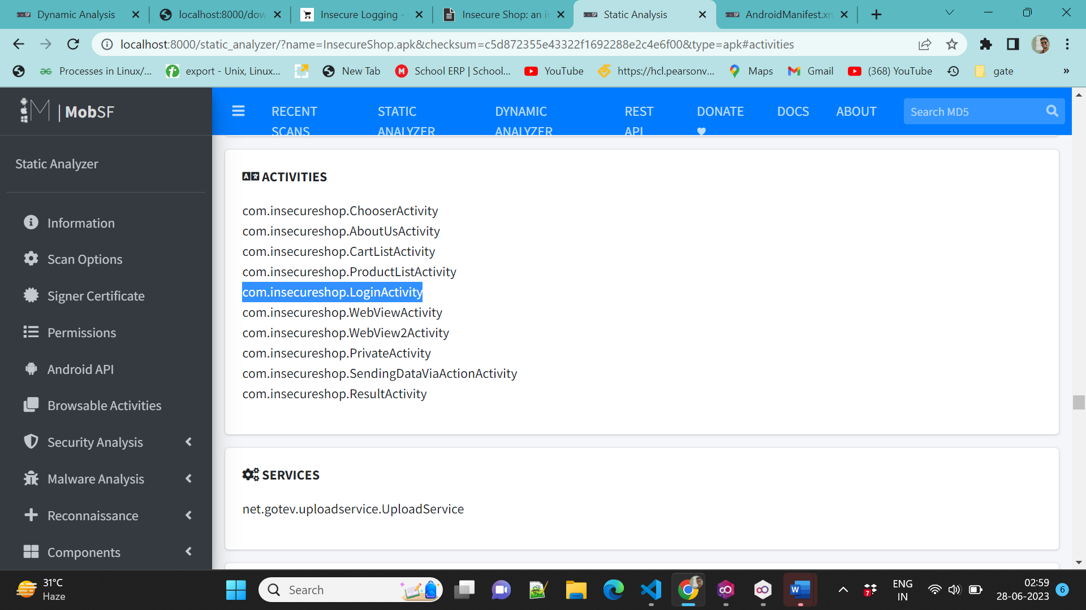

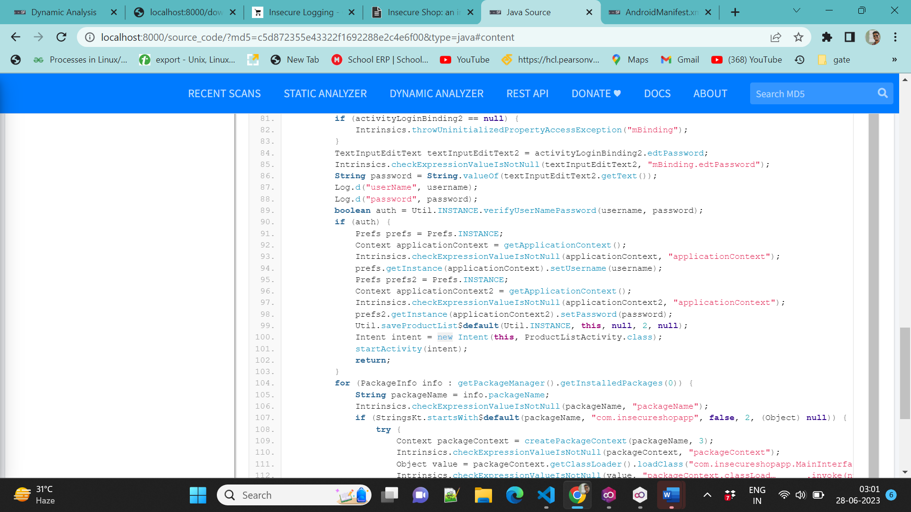

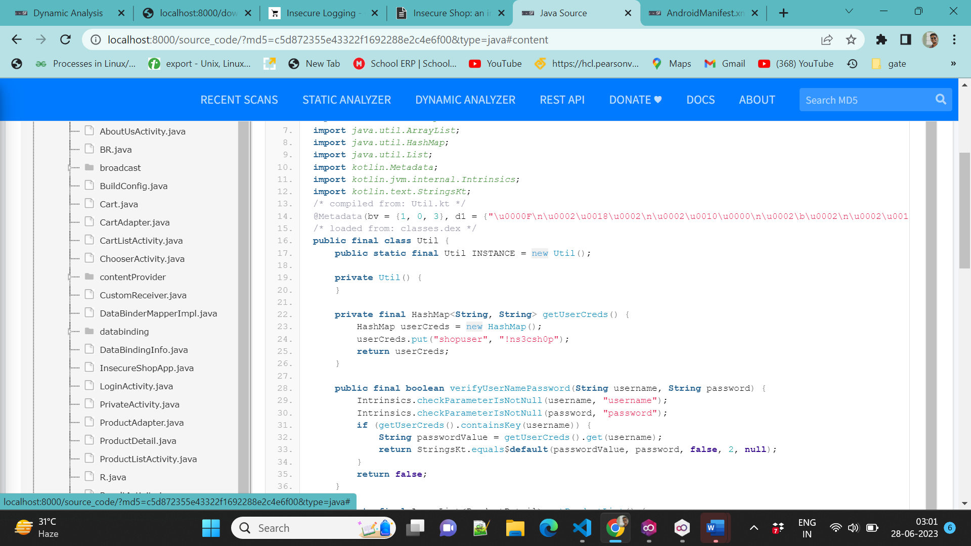

**3.Andro Goat using MobSF**

**1. Network Intercept:**

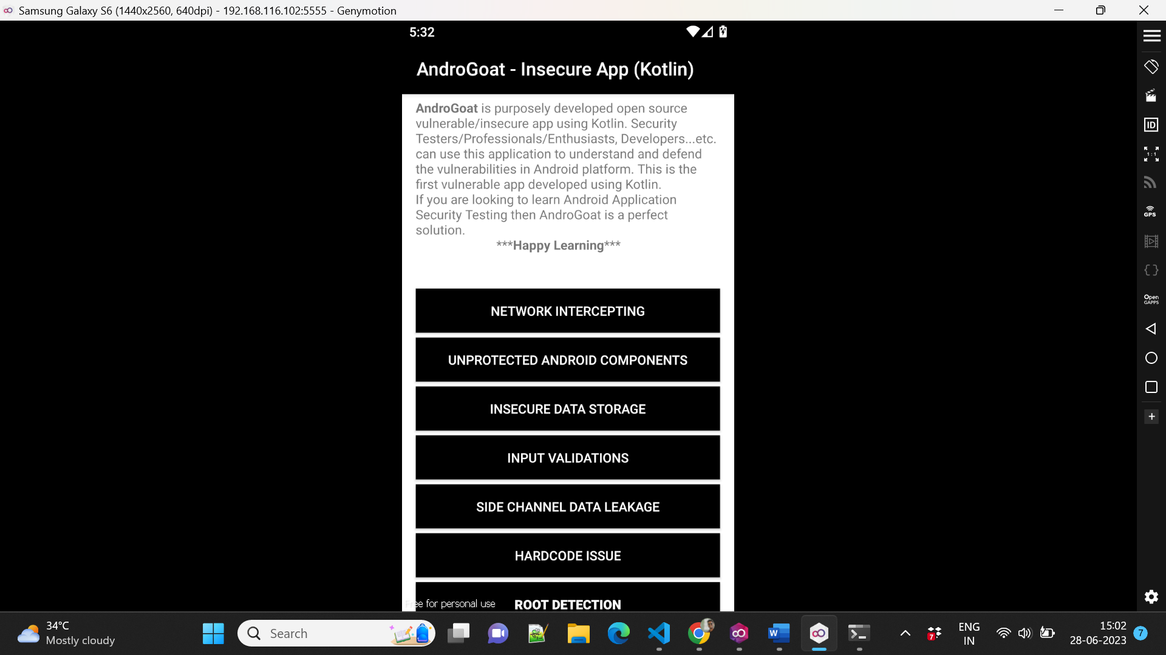

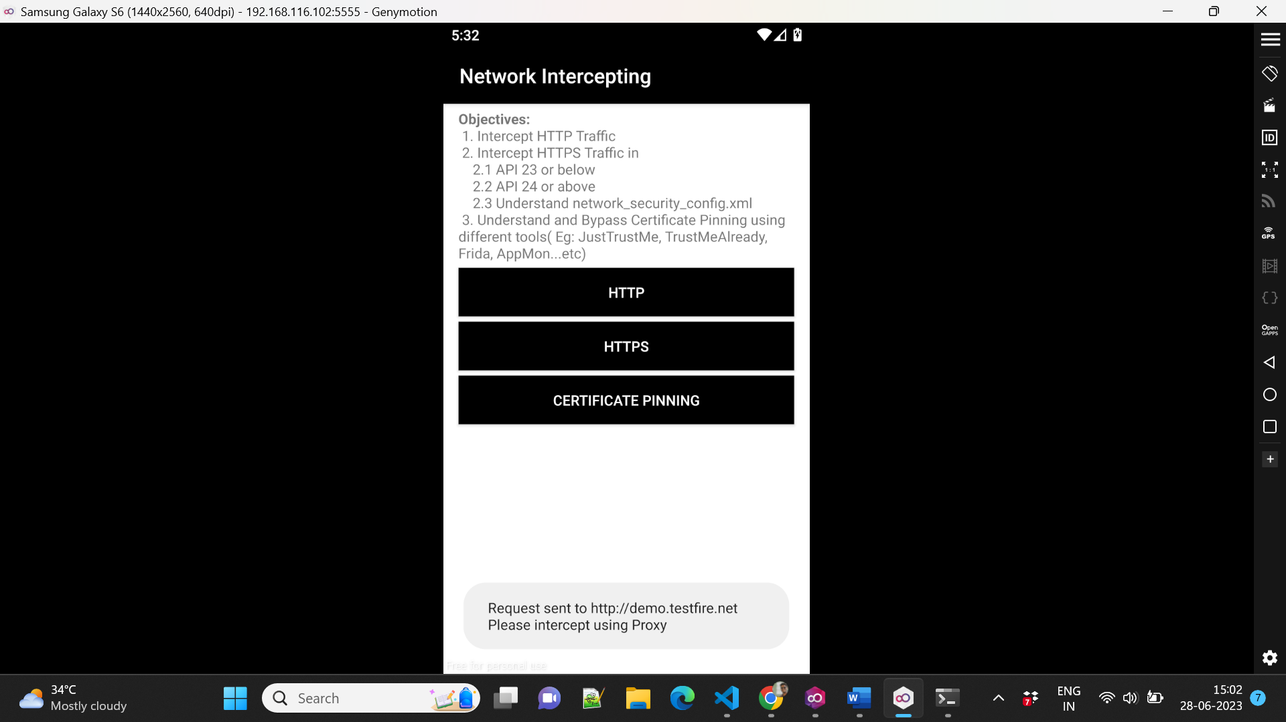

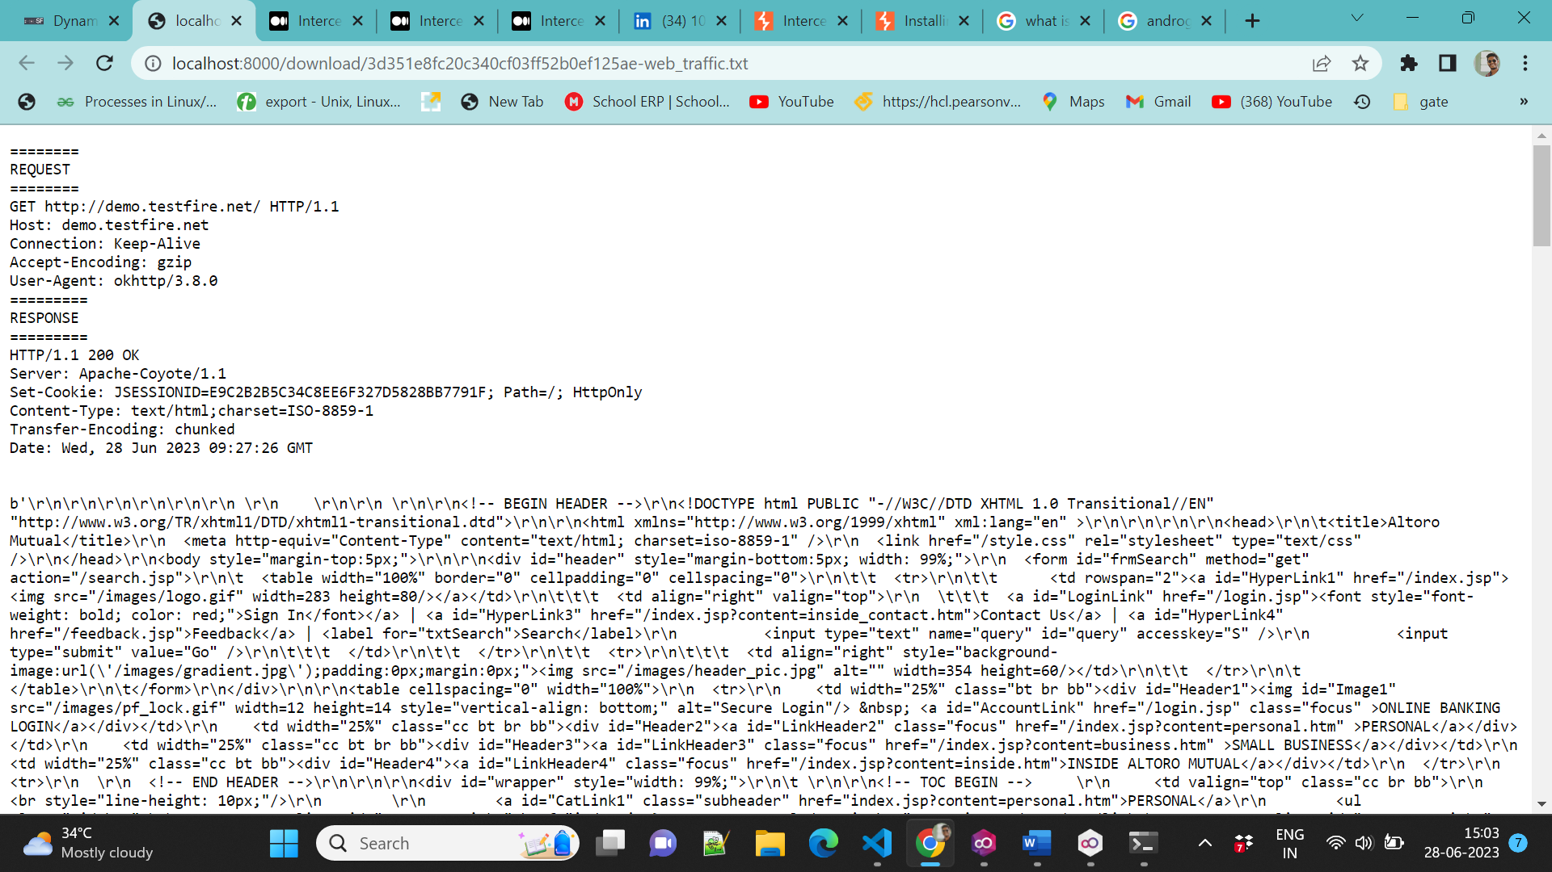

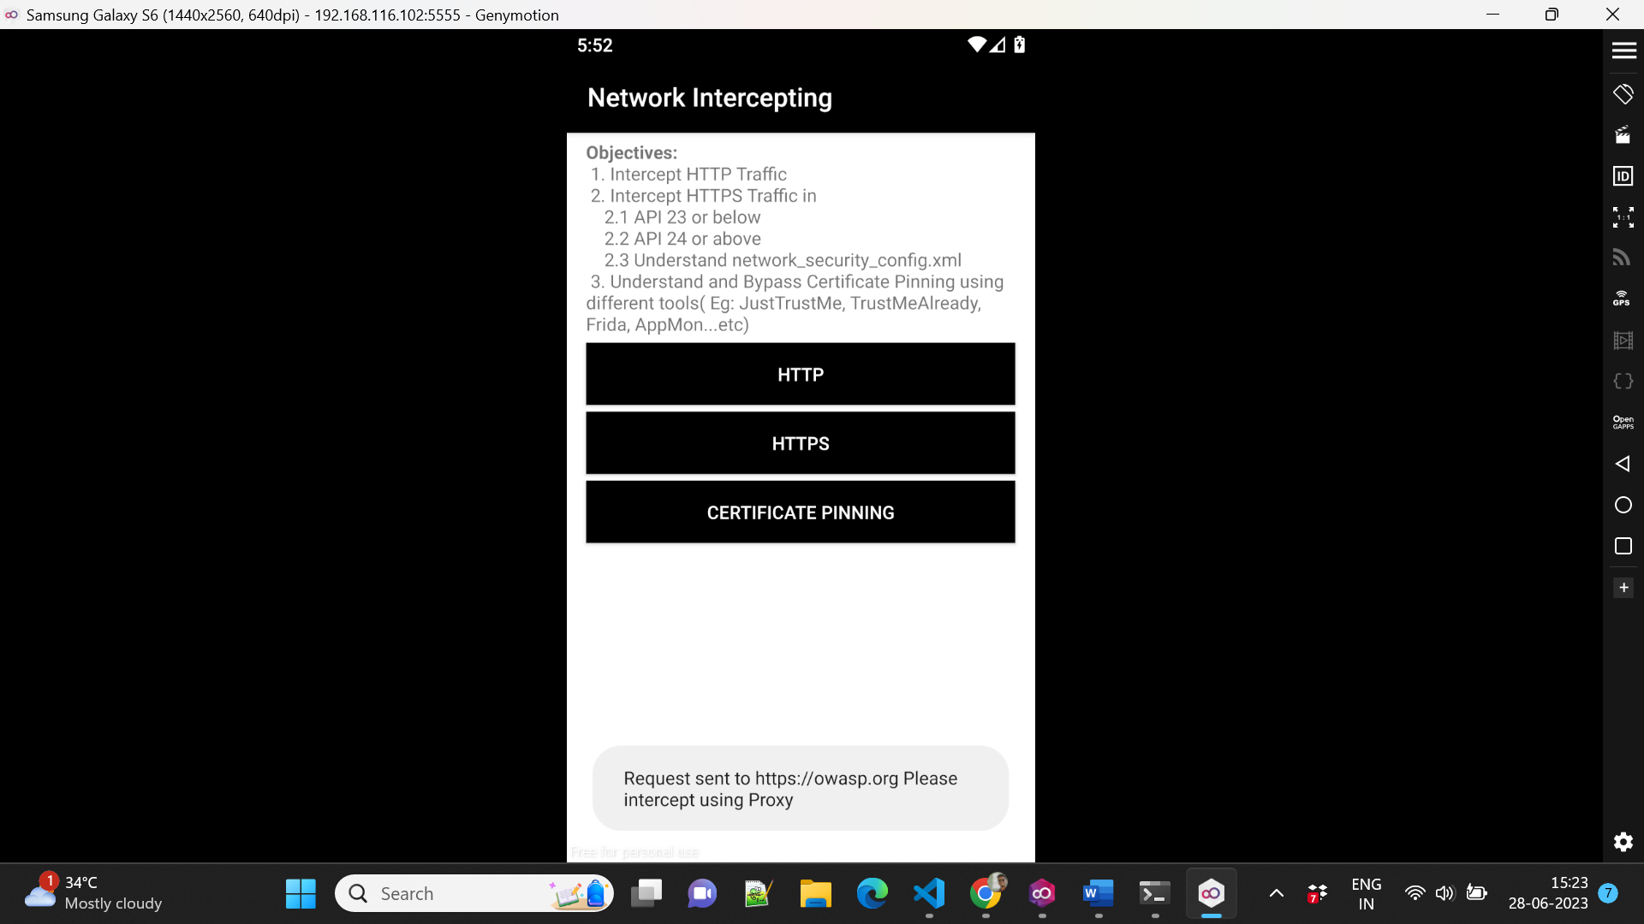

One thing I observed from this HTTPS request intercept is the MobSF proxy doesn’t get the HTTPS information for the Android versions below 6.0 (Marshmallow).But works for the android version 10.0 .

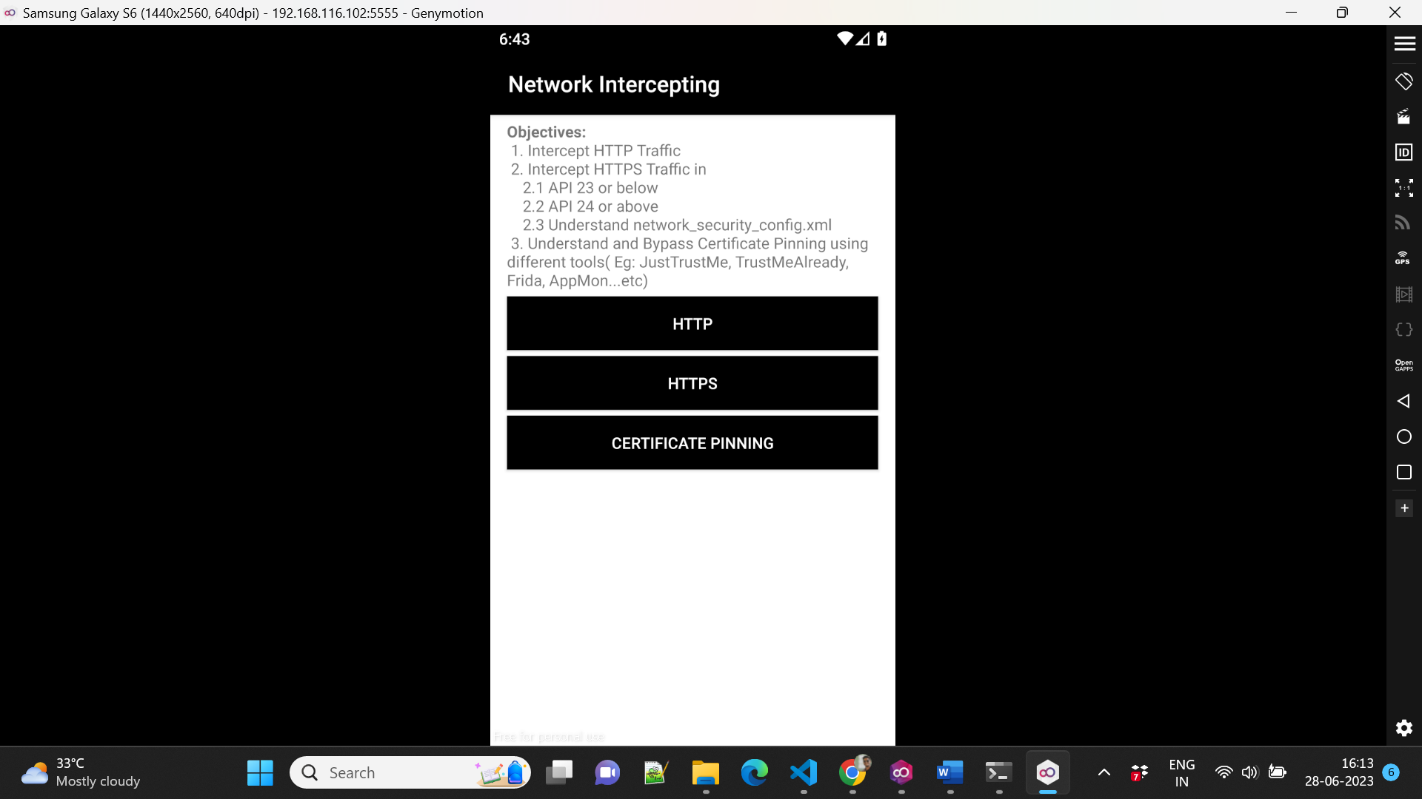

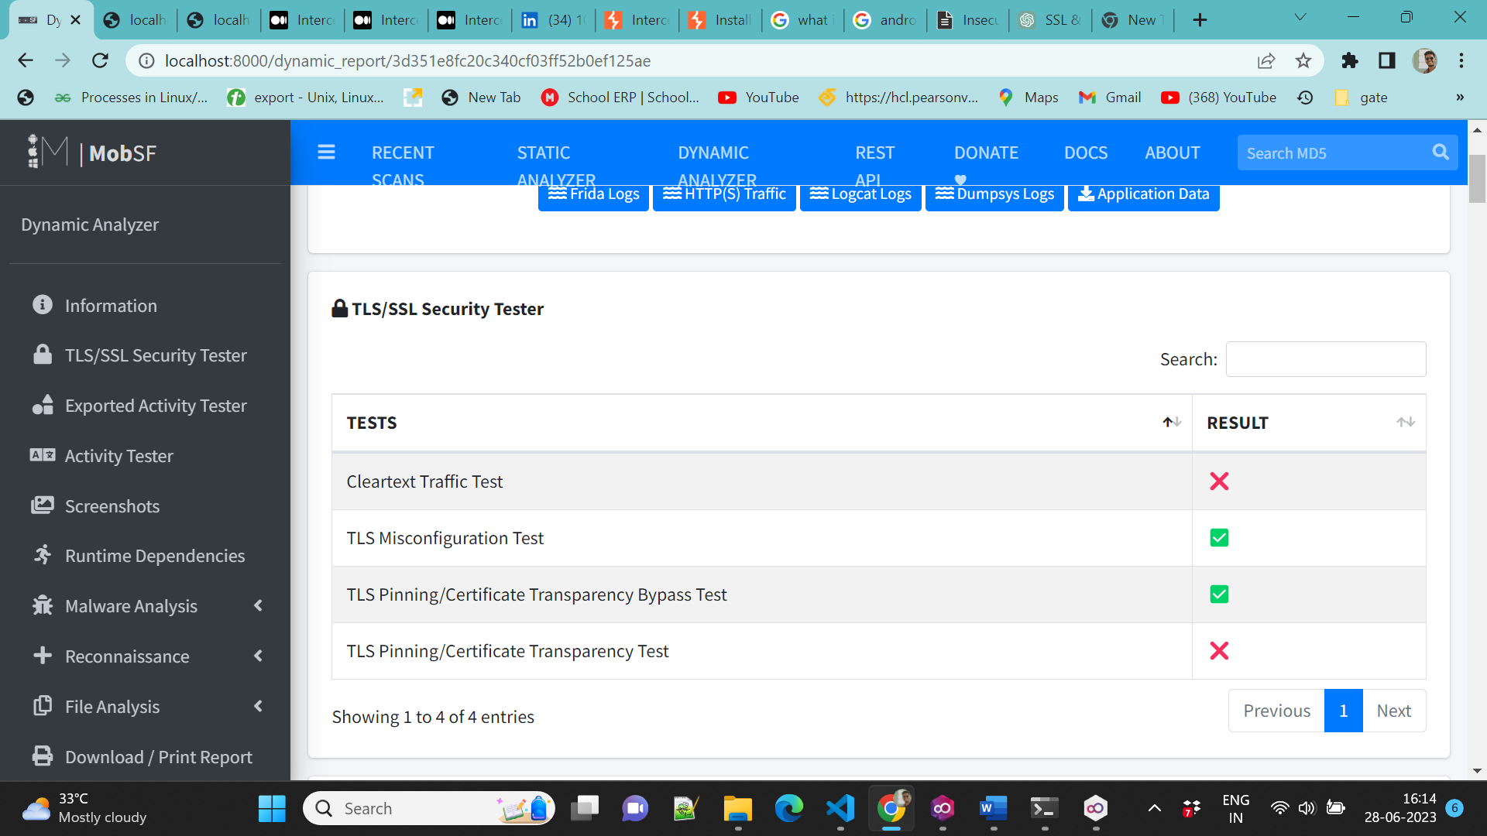

**2. Insecure data storage**

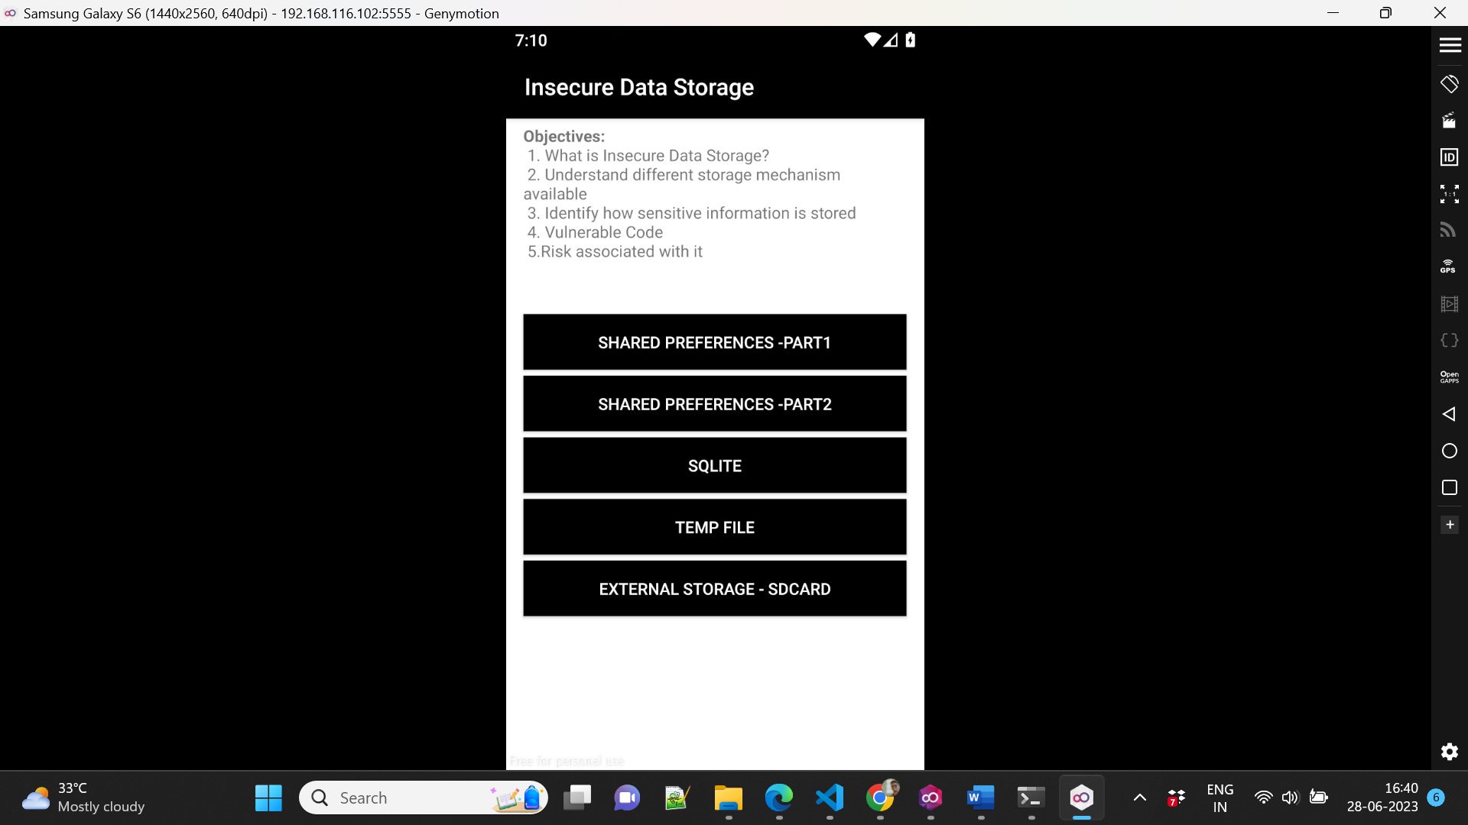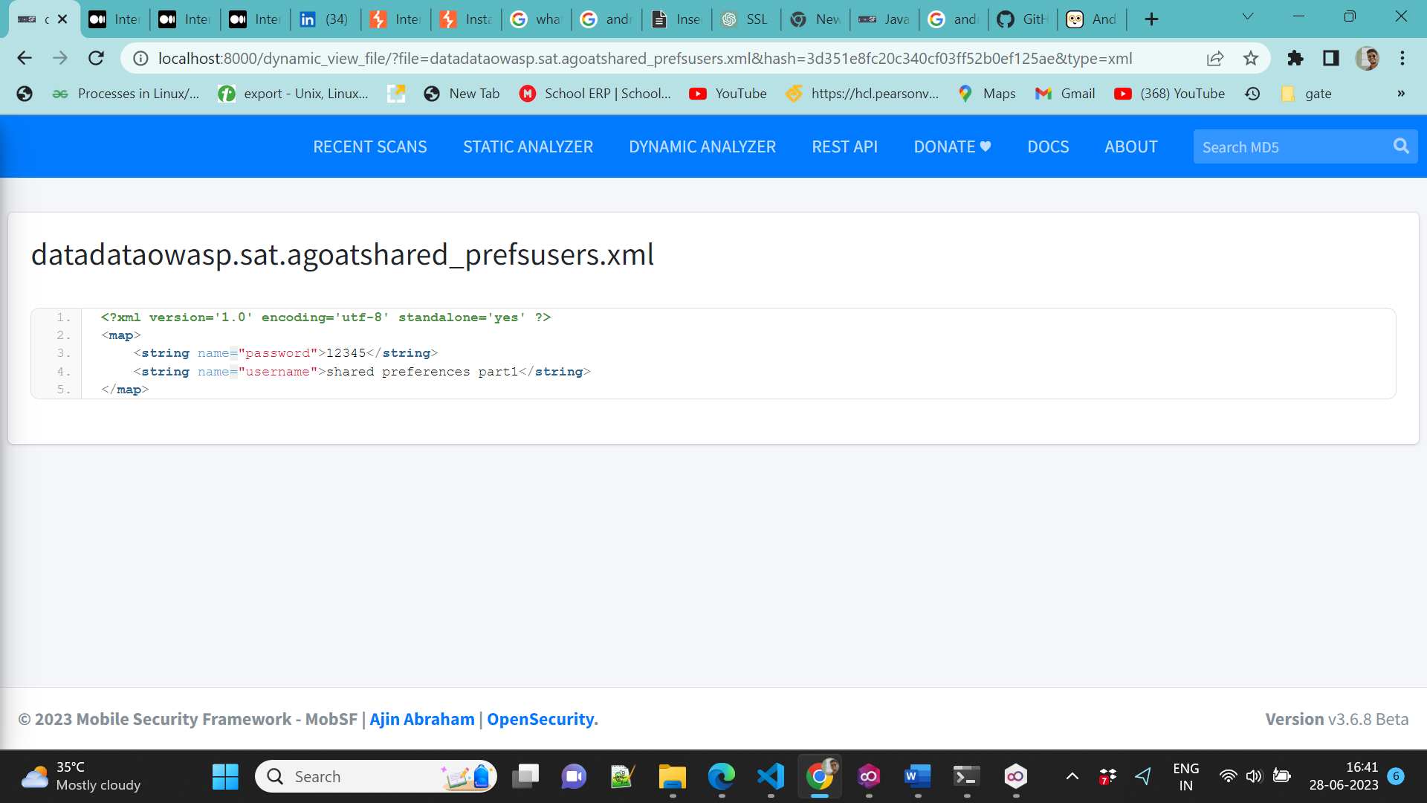

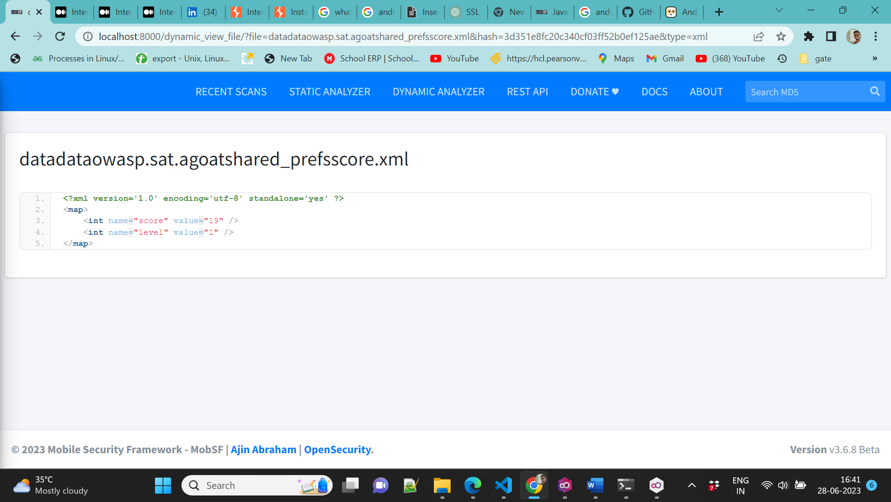

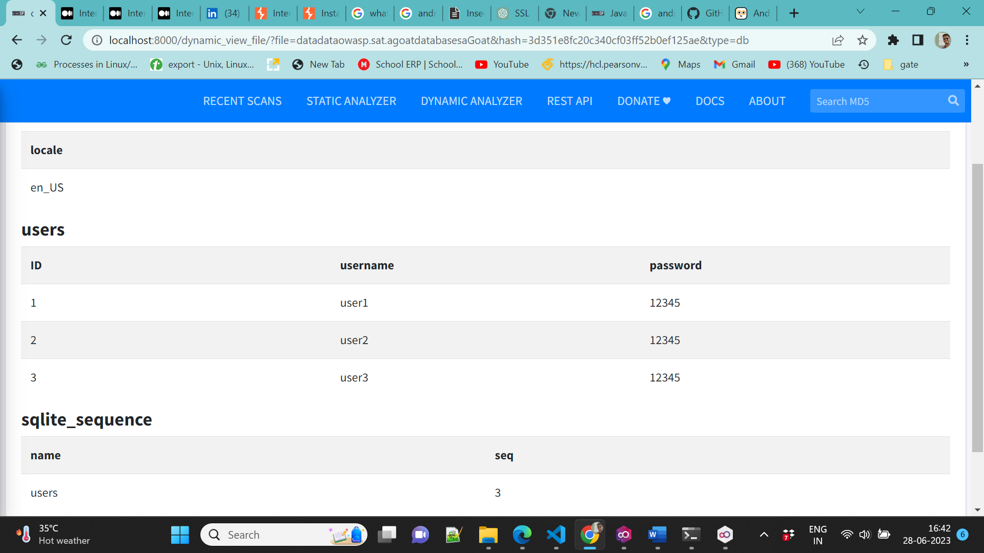

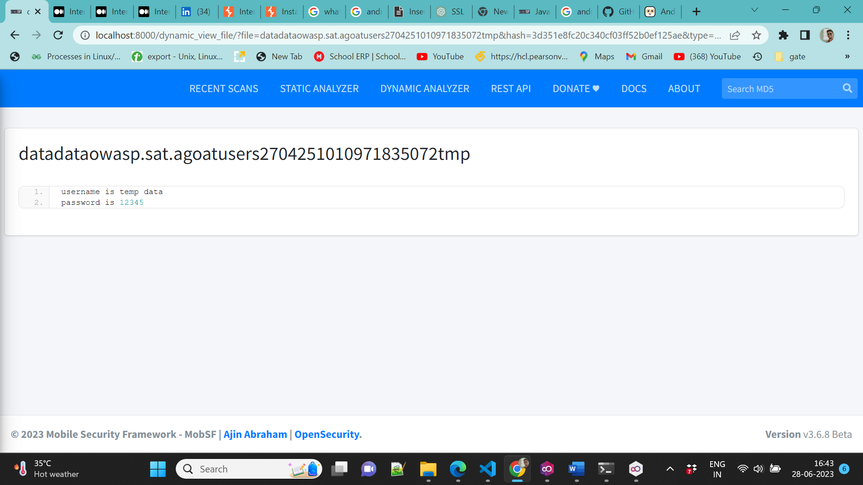

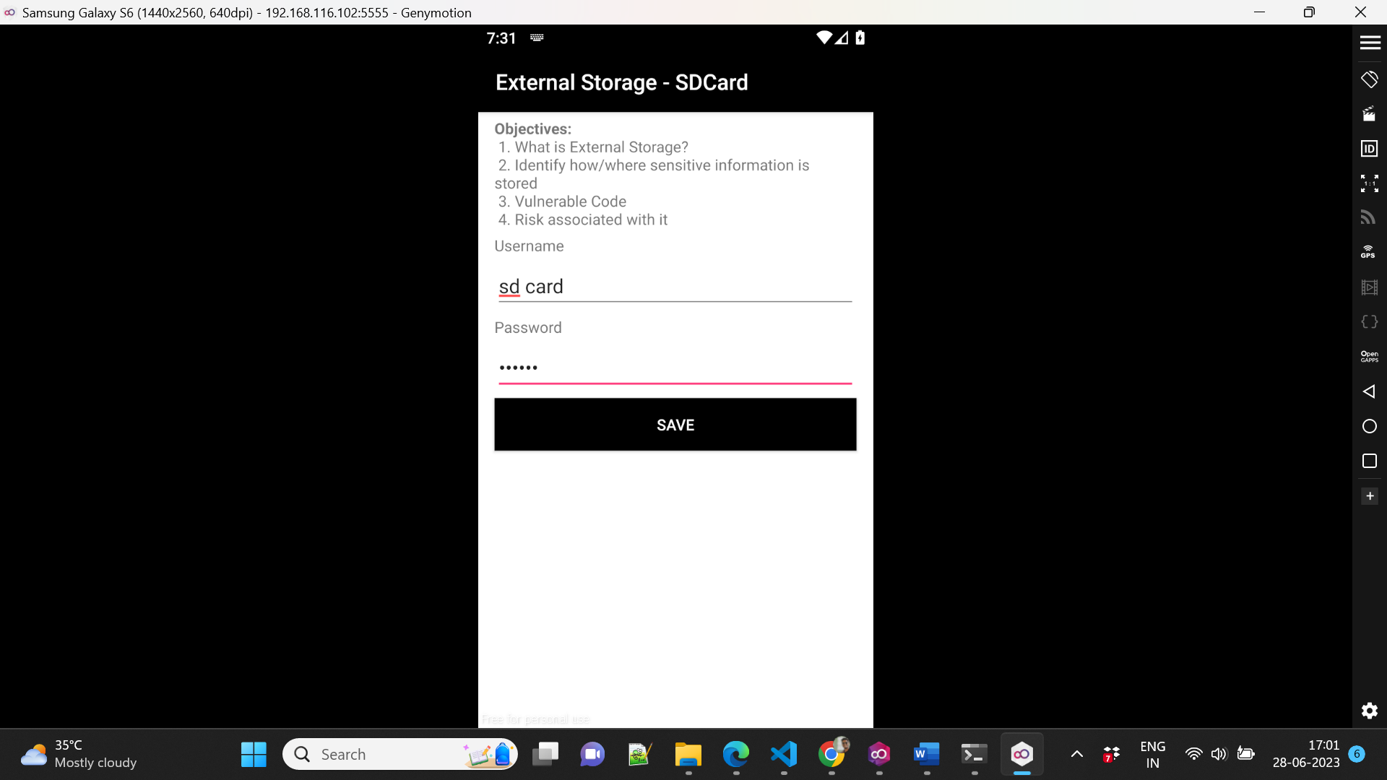

Actually, I find the code where the external data is stored but here data is not saved because we don’t have any external SD card inserted that’s why it is not not saved.

**3. Input Validations**

